

Amy Kellogg
(615) 452-7761
akellogg@tnuct.com

FOR IMMEDIATE RELEASE
January 6, 2011
Jordan Murphy Writes Prize-Winning Essay

Nashville, TN- Jordan Murphy, a Hickman County High School senior, wrote a prize-winning essay for the Utrust statewide writing competition. She wrote about how her sixth grade math teacher at Hickman County Middle School, Lonnie Mayberry, had made a difference in her life. She told how Mayberry used catchy phrases, take-offs on commercials, silly songs, crazy colored chalk and a bright personality to make his classes different and fun. In the process, he changed Murphy’s attitude about math and her approach to learning and tackling tough tasks.

“Mr. Mayberry’s influence also helped me learn that something I hated could be something I loved if I just changed my approach,” wrote Murphy. “I have carried Mr. Mayberry’s ideas with me throughout high school. Thanks to the year I spent in sixth grade math, I will walk into the college of my choice knowing that I can handle any course the university throws at me and have a clear idea of who I am and what I want to do with my life,” Murphy continued.

Utrust Administrator, Dr. Dan Tollett, presented the award to Murphy on Wednesday, January 5 at Hickman County High School. Murphy won $100 for her essay and it will become a permanent part of the Utrust Make A Difference Library and stand as documentation that Lonnie Mayberry is a public school teacher who goes above and beyond what is required of him to make a difference in students’ lives.

“Jordan Murphy has brought honor to Hickman County High School by having her essay selected from thousands submitted statewide,” Tollett said. “I’m confident that Mr. Mayberry appreciated knowing the impact that he had on one of his students. He had to be impressed with Jordan’s expression of gratitude to him.”

Jordan is a student in Orlean Bauman’s twelfth grade Honors English class. Bauman assigned her students to write an essay about a school employee who had made a difference in their lives. Some, including Jordan, entered their essay in the Utrust Writing Competition seeking the $1000 first prize. Others presented their essay to the person about whom it was written. Statewide, only fourteen essays were chosen as prize-winning essays but thousands of school employees each received an essay commending them for what they have done to make a difference in some student’s life.

“We are pleased to have achieved our goal at Utrust by having thousands of people across the state recognizing the contributions of school employees and expressing gratitude to individual employees for making a difference in the lives of students,” Tollett stated.

Utrust is a statewide organization governed by school board members, which assists school boards to develop, recognize and appreciate their employees. Utrust sponsors the School Employee Appreciation Program that promotes eight celebrations during each school year to honor school employee groups. The program is free to member boards.

Visit www.tnuct.com for more information or to read the essay in its entirety.

###
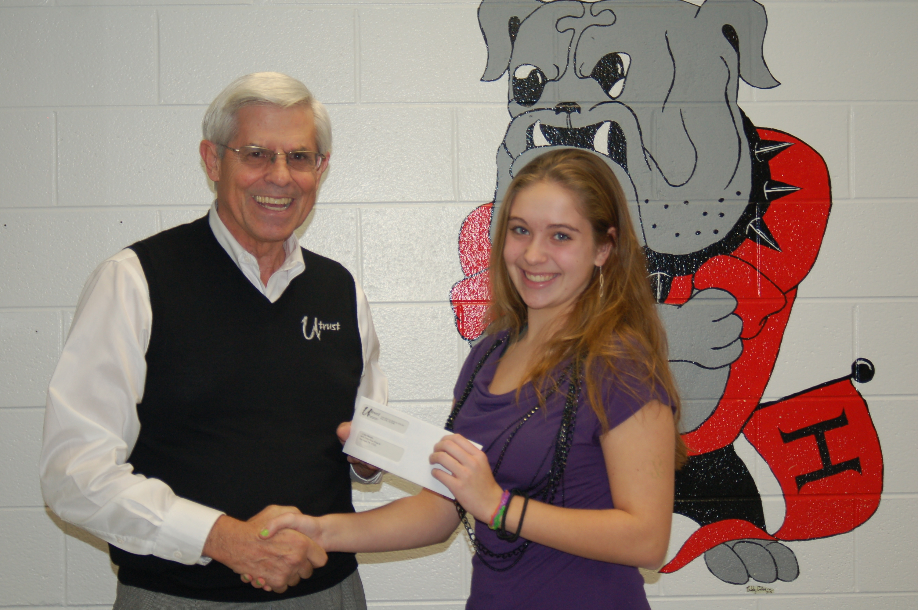
Dr. Dan Tollett and Jordan Murphy

