
Amy Kellogg
615-452-7761
akellogg@tnuct.com

FOR IMMEDIATE RELEASE

January 27, 2011

Sherry Price Writes Prize Winning Essay

Church Hill, TN- Sherry Price, Assistant Principal at Church Hill Intermediate School, wrote a prize-winning essay for the Utrust statewide writing competition. Price’s essay, entitled “Teacher to Teacher” was about her former teacher, Jimmie Dougherty.

“Little did I know that when I entered her eighth grade classroom in 1982 as her student I was about to begin my journey in my career in education. As an impressionable pre-teen, I watched everything she did that year,” Price wrote. “Every student was her favorite (at least on one day or occasion), and she wanted them to know it. I left her class that day with a feeling of excitement and encouragement. I was gong to be just like her,” Price continued.

Ten years later Price fulfilled her dream of being like Ms. Dougherty when she became a teacher. Years later their paths crossed again when they began working across the hall from each other as teachers. Price and Dougherty maintain a close bond working together at Church Hill Intermediate School.

“Her love for teaching, vivacious personality, and willingness to help every child makes her a perfect candidate,” Director Charlotte Britton said of Dougherty. “I am extremely proud of the accomplishments and recognition for Ms. Dougherty. She is so deserving of this tribute. It is uplifting that we have employees who give 110% everyday. I am so proud of our dedicated employees who make a difference in the lives of Hawkins County Schools’ students,” Britton continued.
Utrust Administrator, Dr. Dan Tollett, presented the award to Price on Tuesday, January 25th at Church Hill Intermediate School. Price won $100 for her essay and it will be a permanent part of the Utrust Make A Difference Library to document that Jimmie Dougherty has made a difference in the lives of her students.

“Hawkins County is fortunate to have a superintendent of schools and a board of education that recognizes and continually shows appreciation for school employees,” Dan Tollett said. “Hawkins County has been recognized two years in a row by Utrust for having the best employee appreciation program in the state,” he continued. “Nedra Jackson does a fantastic job of coordinating the system-wide program to help students develop an attitude of gratitude while honoring school employees.”

Utrust is a statewide organization governed by school board members, which assists school boards to develop, recognize and appreciate their employees. Utrust sponsors the school Employee Appreciation Program that promotes eight celebrations during each school year to honor school employee groups. The program uses a student A-Team in each school to plan and implement the program. The annual writing competition is part of the program.

Visit www.tnuct.com for more information or to read the essay in its entirety.

###

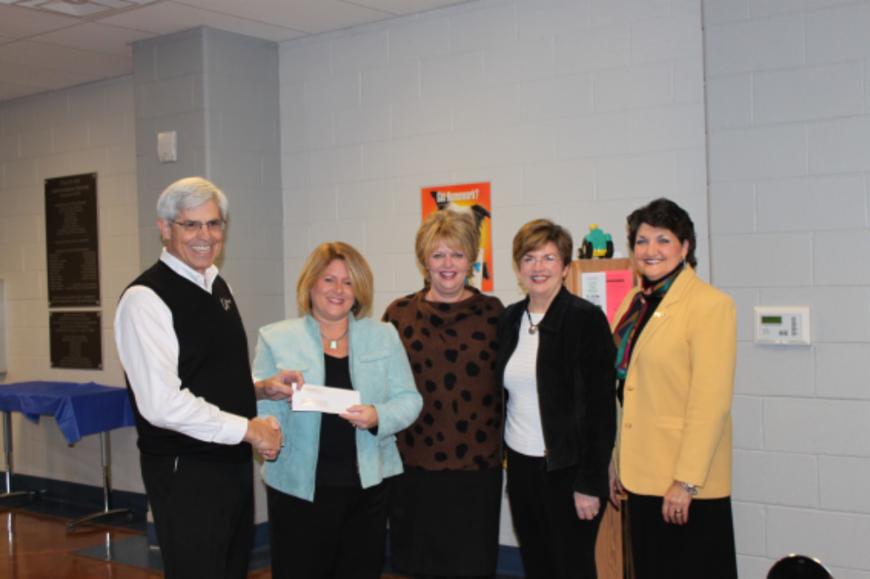
Dan Tollett, Sherry Price, Jimmie Dougherty, Charlotte Britton, Nedra Jackson

