

**Memo to School Board from Superintendent.**  Use the sample memo provided or create your own to encourage school board participation in the upcoming Bus Driver Appreciation Day with the theme Road Trip Games.

See Page 2 for the sample letter.

**Resolution of Appreciation.** This sample resolution declares September 17, 2020

as Bus Driver Day.

See Page 3 for the sample resolution.

**News Release.** Send the included news release (or write your own) to

local media outlets.

See Page 4 for the sample news release.

**Presentation to the Board.** Create a short presentation for the board members informing of them of activities that took place during Bus Driver Day.

See Page 5 for the idea.

**Website Poster.** Use your system website to promote Bus Driver Appreciation Day. Copy and paste the artwork provided

or create your own.

See Page 6 for the website poster..

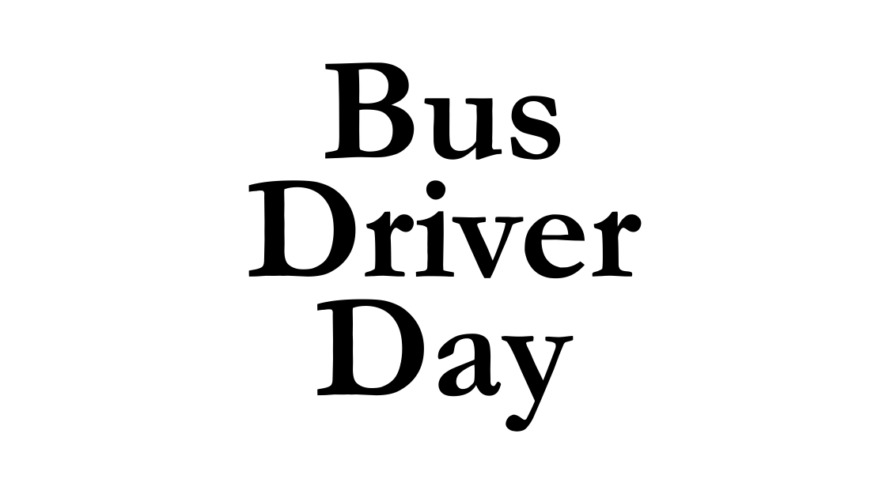



To: Board of Education

From: Superintendent

Re: Bus Driver Appreciation Day

Date: September 17, 2020

We are beginning a new year of appreciation using the Utrust Appreciation Program. The overall theme this year will be **Game On**. The first theme will be **Road Trip Games** for Bus Driver Appreciation Day. Utrust has suggested that the board declare September 17, 2020 as Bus Driver Appreciation Day.

Attached to this Memo is the Resolution of Appreciation officially establishing September 17, 2020 as Bus Driver Appreciation Day in our school system.  I encourage you to adopt the resolution.

Bus drivers are very important to the success of our school system.  They carry the students safely to and from school every day. They must be ready for action during emergency situations. Without them our school system could not function properly. Using the theme **Road Trip Games**, our students will have fun showing the bus drivers how much they are valued and appreciated. In turn, both the morale of bus drivers and their relationship with the students will be improved.

We strongly believe participating in the Utrust Appreciation Program will increase employee morale and teach students the importance

of showing appreciation to school employees who are making a

difference in their lives.

Please join me in honoring the bus drivers in our school system.







WHEREAS, school bus drivers have an opportunity to ensure that a student’s school day begins and ends in a positive manner by the way they greet each student in the morning and bid them farewell in the afternoon; and

WHEREAS, school bus drivers have a tremendous responsibility getting students safely to and from school every day; and

WHEREAS, bus drivers are extremely valuable employees.  Without them, many students would not be able to get to school and our school system would not run properly and smoothly; and

WHEREAS, bus drivers must be ready to handle any emergency situations that might occur; and

WHEREAS, the superintendent and school board greatly appreciate the commitment, competence and dedication of our school bus drivers and wish to honor them for their service to our school system.

THEREFORE, BE IT RESOLVED, that the ______________ Board of Education hereby establishes September 17, 2020 as Bus Driver Appreciation Day in _______________ Schools; and

BE IT FURTHER RESOLVED THAT the Board encourages students, parents and staff in each school to join us on that day in expressing appreciation to the bus drivers

for all they do.

Adopted by the _____________ Board of Education in regular session on _____________, 2020.

_________________________                      _________________________

Superintendent                                                   Board Chairman





FOR IMMEDIATE RELEASE

Date ___________________

It’s another great year of appreciation in _________________ Schools! During this school year, students will use the **overall theme of Game On!** to appreciate and honor every group of school staff throughout this school year.

The _______________ Board of Education has passed a resolution declaring September 17, 2020 as **Bus Driver Day**. The **theme Road Trip Games** will be used to honor the hard-working and valuable bus drivers.

Superintendent ___________________________ and the ____________ Board of Education recognize bus drivers play a vital role in the success of the schools. Superintendent __________ said, “We realize the importance of our bus drivers because they have a tremendous responsibility getting our students to and from school safely every day. For that we are thankful and will honor them on their special day.” _________ continued, “Bus drivers are the first school employee to see many children every day.  They can help to make sure their day starts in a pleasant and positive manner.”

Bus Driver Appreciation Day is one of eight (8) days set apart throughout the year to honor school system employees as part of the Utrust Appreciation Program.  The Utrust Appreciation Program promotes student leadership in recognizing the work of school employees and expressing appreciation to them for what they do.

Activities for each appreciation day are planned and led by student leadership teams in each school. These student leadership teams create an opportunity for learning and help in developing an attitude of gratitude among classmates. Schools participating in the Utrust Appreciation Program enjoy a better working and learning environment because the staff feel more appreciated.

Although the appreciation days are led by students, the public is encouraged to join the

students in expressing gratitude to bus drivers, especially on this day.

(Note: You might want to attach a copy of the resolution and a photo of the chair

presenting it to the bus driver(s) with the most years of service or the director

of transportation. This will help to increase the likelihood that the local

newspaper will run the story.)







Prepare a short presentation for the next Board meeting informing the school board members of the great things that happened on **Bus Driver Appreciation Day** using the theme **Road Trip Games**.

Choose a few of the most interesting activities that happened in your school district and highlight them.  In the 5-minute presentation consider including pictures, videos and quotes from students and coordinators.

The goal of the presentation is to inform the board members of how the program is making a difference in the students and staff in the schools. It also gives board members a chance to join in celebrating the **bus drivers** and to commend students for their appreciation efforts.



