

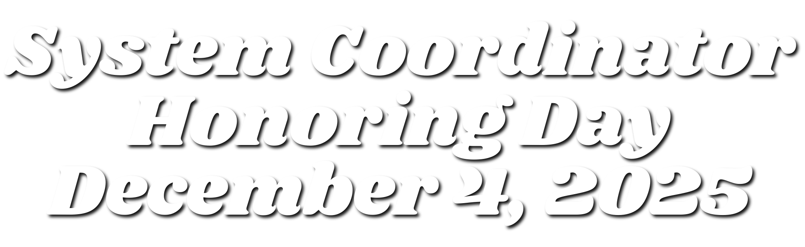

Printable Poster for Office p.2

Sample Resolution p.3
Sample Letter from Superintendent to System Coordinator p.4
Sample Letter from School Coordinator to System Coordinator p.5

To Do Lists p.6

Website & Social Graphics p.7









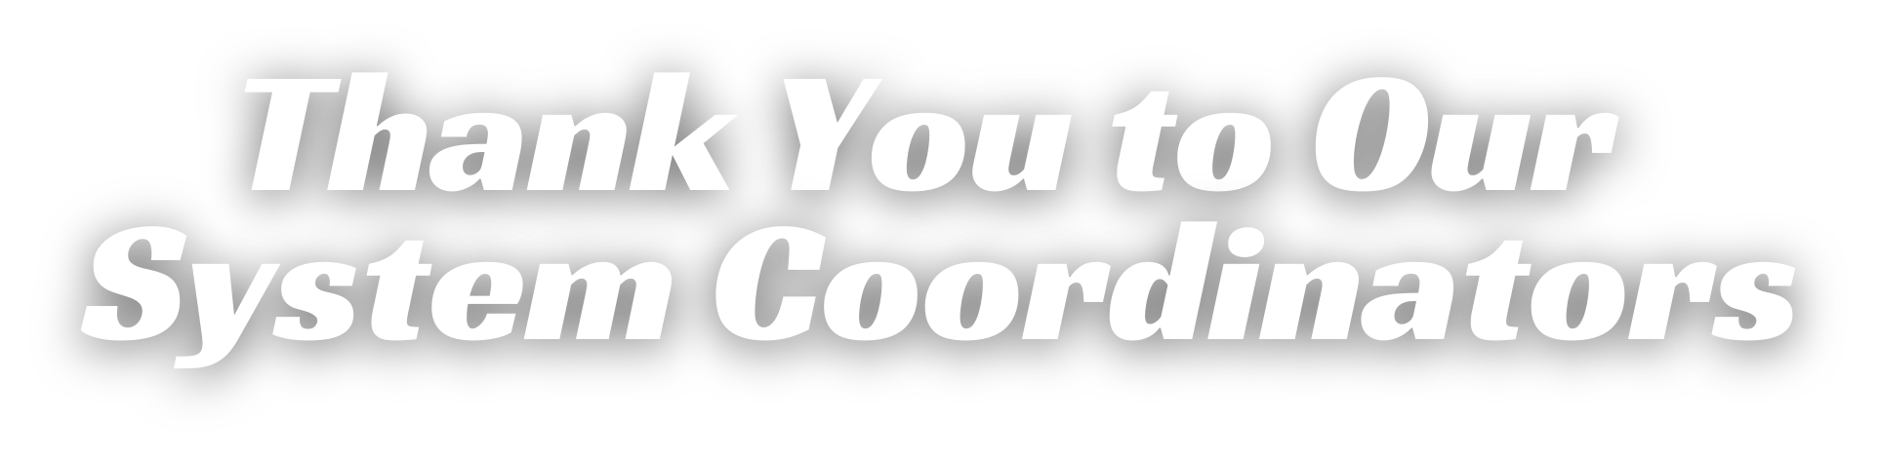




By the Board of Education
SSyysstteemm CCoooorrddiinnaattoorr AApppprreecciiaattiioonn DDaayy RREESSOOLLUUTTIIOONN OOFF AAPPPPRREECCIIAATTIIOONN

WHEREAS, the school board and superintendent consider it essential for our students to develop the skill of recognizing and expressing appreciation to those who make their lives better each day; and

WHEREAS, the school board and superintendent recognize that the expression of appreciation is a major factor in staff morale; and

WHEREAS, , the System Coordinator of the Utrust Appreciation
Program plays a key role in determining the success of the program and the resulting morale of employees in our schools; and

WHEREAS, the System Coordinator supports and encourages school coordinators as they work with student leadership teams to plan, conduct and document celebrations in their schools; and

WHEREAS, the System Coordinator keeps the school board informed about the celebrations of activities related to the expression of appreciation within the schools, including opportunities for involvement of school board members in those celebrations; and

NOW, THEREFORE BE IT RESOLVED that the board acknowledges the positive impact appreciation has on the overall culture of the schools in our system and expresses deep appreciation for their continuous demonstration of leadership by helping to spread appreciation in our schools; and

BE IT FURTHER RESOLVED that the Board of Education hereby establishes
Thursday, December 4, 2025 as System Coordinator Appreciation Day; and

BE IT FURTHER RESOLVED that the board encourages our school community to express appreciation for our System Coordinator.

Approved by the ______________________ Board of Education in regular session on , 2025.

_______________________________________________ _________________________________________________ Superintendent Board Chairman


From Superintendent to System Coordinator
SSyysstteemm CCoooorrddiinnaattoorr AApppprreecciiaattiioonn DDaayy
SSAAMMPPLLEE LLEETTTTEERR

Dear ,

Thank you for the outstanding job that you have done as System Coordinator for the Utrust Appreciation Program in Schools.
I consider it very important that our students learn to recognize what school employees do for them each day and beyond that, to express sincere appreciation to them for something specific that they have done. The Utrust Appreciation Program under your leadership has made a big difference in creating a culture of appreciation in each of our schools.

You have monitored the progress of the appreciation programs in each of our schools and you have been a consistent source of encouragement to the school coordinators and the advisers who work directly with the students in each of our schools. I have enjoyed observing your work and
I deeply appreciate the leadership that you have shown for this program.

I know that having an excellent appreciation program in our schools is dependent on having an excellent system coordinator. That’s why I chose you to lead our program. You set an example of caring about our students and you are committed to having an outstanding appreciation program in which our students grow in their ability to recognize what others do for them each day and to become confident in their ability to sincerely express appreciation for what they have done.

Sincerely, Superintendent


From School Coordinator to System Coordinator
SSyysstteemm CCoooorrddiinnaattoorr AApppprreecciiaattiioonn DDaayy
SSAAMMPPLLEE LLEETTTTEERR

Dear System Coordinator,

Thank you for your incredible work as System Coordinator for the Utrust Appreciation Program in Schools. Your leadership and
dedication have been essential in helping everything run smoothly for me as the school coordinator. Your guidance and support ensure the program’s success, making it easier for me to focus on engaging students and staff in meaningful acts of appreciation.

Your commitment to fostering a culture of gratitude has a lasting impact on our schools. I truly admire the example you set and the difference you make in encouraging students to recognize and express appreciation for the efforts of school employees. Thank you for all you do to make this program such a success!

Sincerely,

School Coordinator
_ School













informing
board of
appreciation
days
ensuring
schools get
appreciation
grants
appreciation
modifying
and sending
news
releases
cheering
on school
coordinators

A GREAT SYSTEM COORDINATOR ENSURES A GREAT APPRECIATION PROGRAM. WE HAVE THE BEST ONE AROUND!
preparing
resolutions
for board
adoption
celebrations
commenting
on Facebook
posts
posting
website
posters



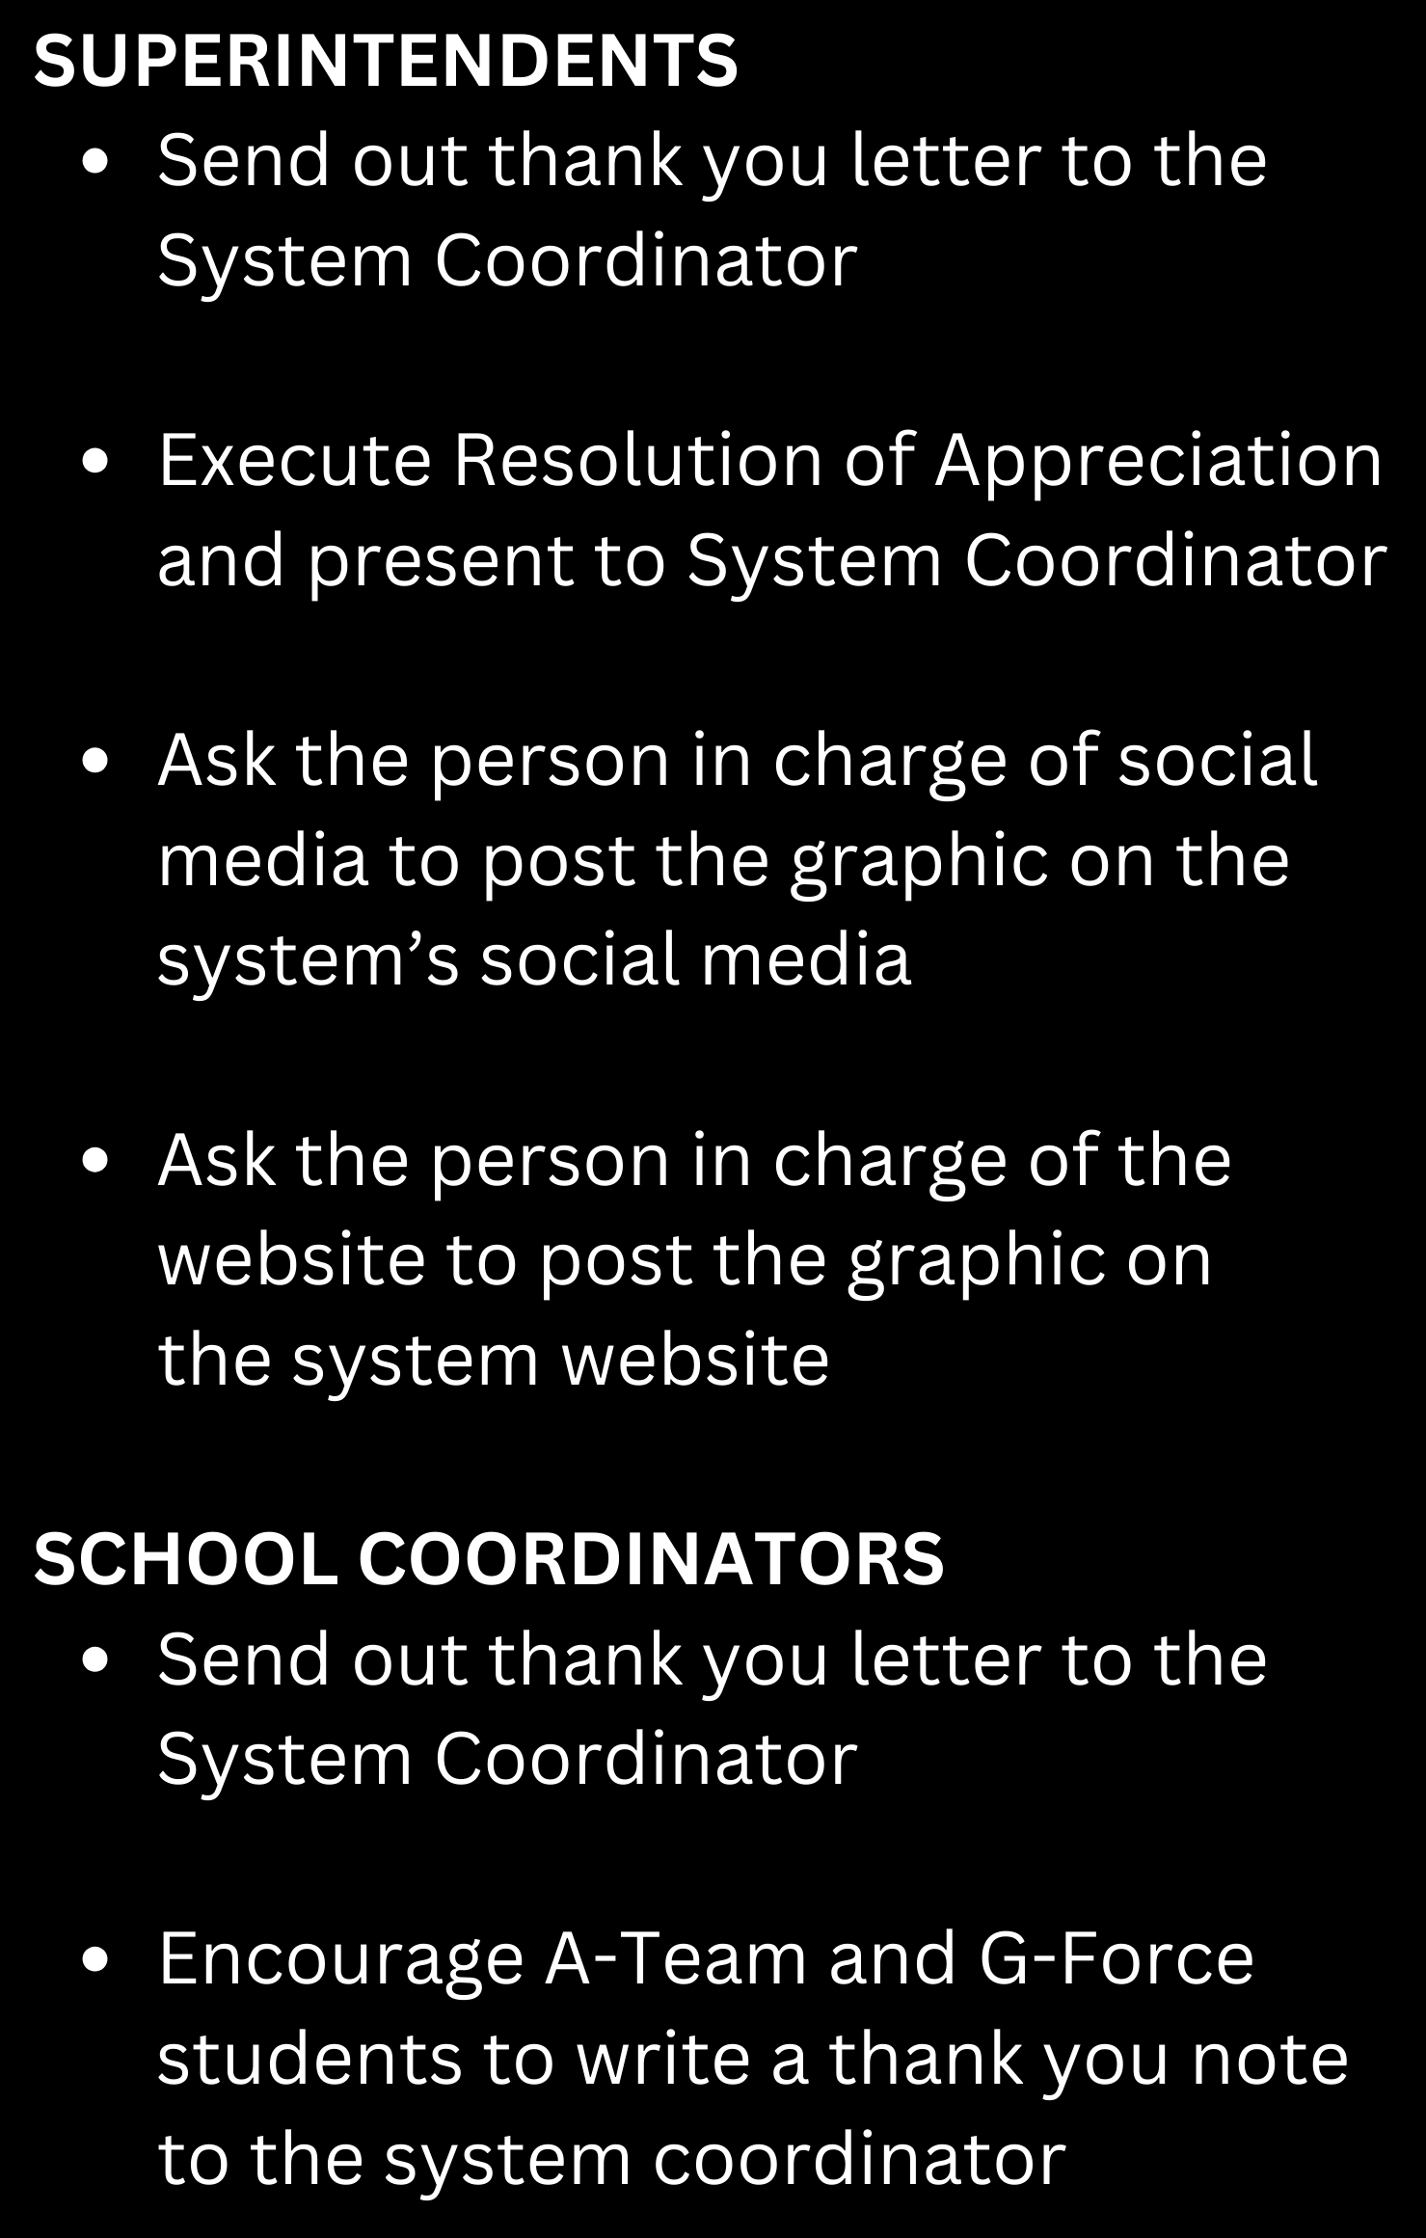


Website Graphic Click to Download!

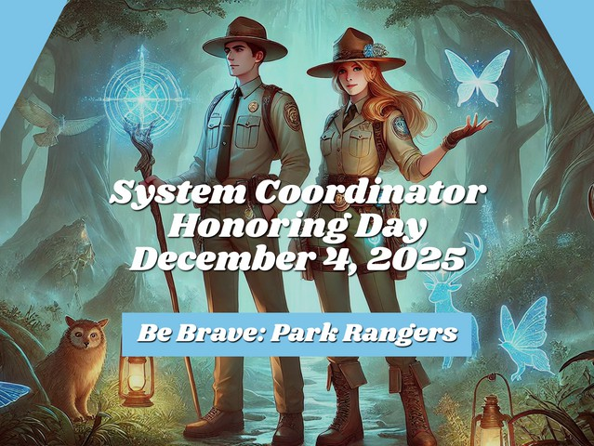

Social Graphic Click to Download!




We are so fortunate to have you in the role of system coordinator. You play such an important part to the success of the Utrust Appreciation Program in each of your schools. We appreciate it when you support school coordinators as they plan out the celebrations through emails sent sharing necessary information and words of encouragement for a job well done and comments you make on facebook to show your support of the celebrations.

Thank you for being the liaison with the board and superintendent and sharing the great things happening in your schools with them.
It is important for everyone to understand the impact appreciation has on the overall culture of the schools in your system and you have done that well. You continuously demonstrate your leadership by helping to spread appreciation in your schools through your words.

We know that great system coordinators result in great appreciation programs. The Utrust Appreciation Program simply wouldn’t make the most difference in the lives of staff and students without you.
We are thankful for all you do to make this program so successful. Thank you for a job well done!

From Dr. Dan Tollett, Kristi Coleman and Sue Bonzell at Utrust

