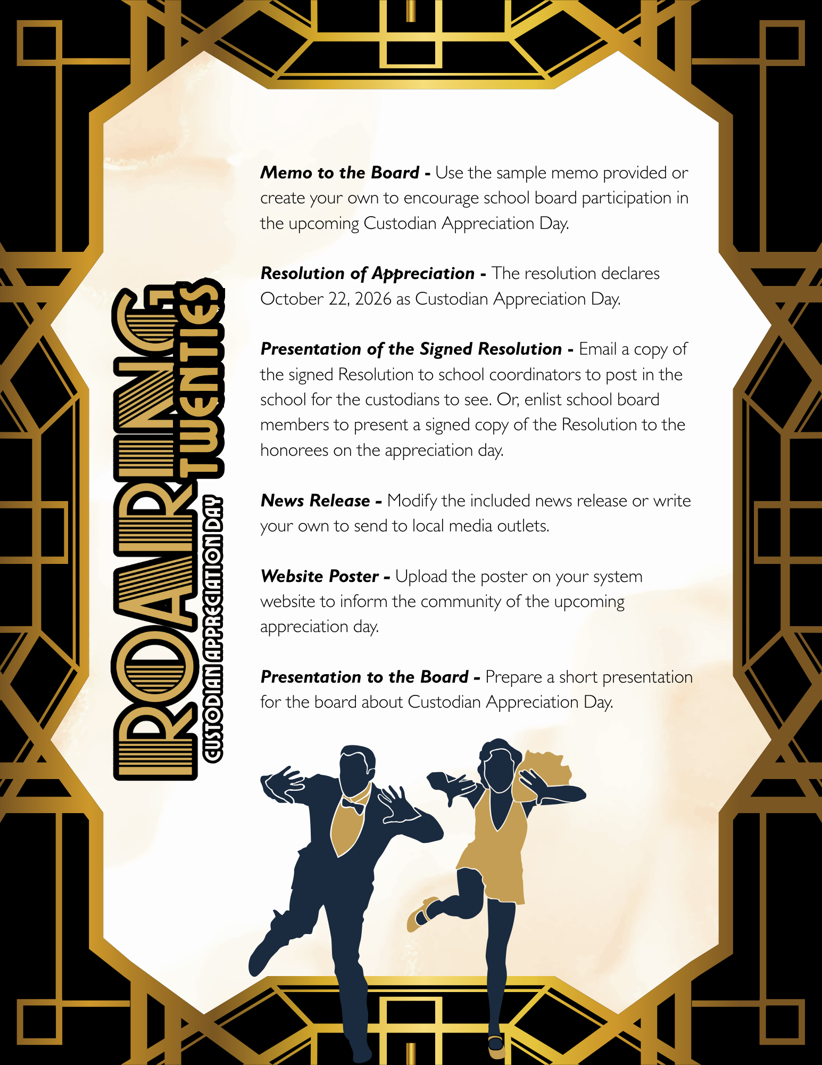


TO: Board of Education
FROM: Superintendent
RE: Custodian Appreciation Day
DATE: [Insert Date]
The next appreciation day in the Utrust Appreciation Program is Custodian Appreciation Day, scheduled for [Insert Date].
This year’s theme is Appreciation Through the Eras: 1920s Edition, celebrating a decade known for progress, innovation, and the spirit of hard work—qualities our custodians demonstrate each and every day.
Attached is the Resolution of Appreciation. Please consider adopting it to honor this exceptional group of individuals who play a vital role in our school system.
Through the 1920s edition theme, we recognize the dedication and pride our custodians bring to their work. Just as the 1920s represented growth and forward momentum, our custodial teams quietly and consistently lay the foundation for success in our schools. Their attention to detail, commitment to safety, and tireless efforts ensure that students and staff learn and work in clean, welcoming, and well-maintained environments.
Please join me in supporting and participating in the Utrust Appreciation Program. We look forward to a meaningful celebration as we express our sincere appreciation to our custodians for their hard work, reliability, and lasting impact on our school community.



WHEREAS, custodians play a vital role in supporting the educational experience by maintaining clean, safe, and welcoming school environments; and
WHEREAS, they work diligently behind the scenes to ensure that classrooms, hallways, cafeterias, and common areas are well-maintained and ready each day for students and staff; and
WHEREAS, our custodians demonstrate a strong work ethic, attention to detail, and a deep sense of responsibility that contribute directly to the health, safety, and overall success of our schools; and
WHEREAS, they foster environments where students and staff can thrive by providing orderly and well-cared-for facilities that support learning and school pride; and
WHEREAS, as part of this year’s “Appreciation Through the Eras: 1920s Edition” celebration, we recognize that the spirit of hard work, dedication, and forward progress—hallmarks of the 1920s—are reflected in the daily efforts of our custodial teams; and
WHEREAS, their reliability, professionalism, and commitment are essential to the daily operations and long-term success of our schools;
NOW, THEREFORE, BE IT RESOLVED that the _______________ Board of Education hereby designates October 22, 2026, as Custodian Appreciation Day in all schools across the district; and
BE IT FURTHER RESOLVED that the Board extends its heartfelt appreciation to the custodians for their unwavering dedication and encourages students, staff, and the community to join in recognizing and celebrating their service and contributions.
Approved by the _______________ Board of Education in regular session on _______________, 2026.
_________________ _________________
Superintendent Board Chairman

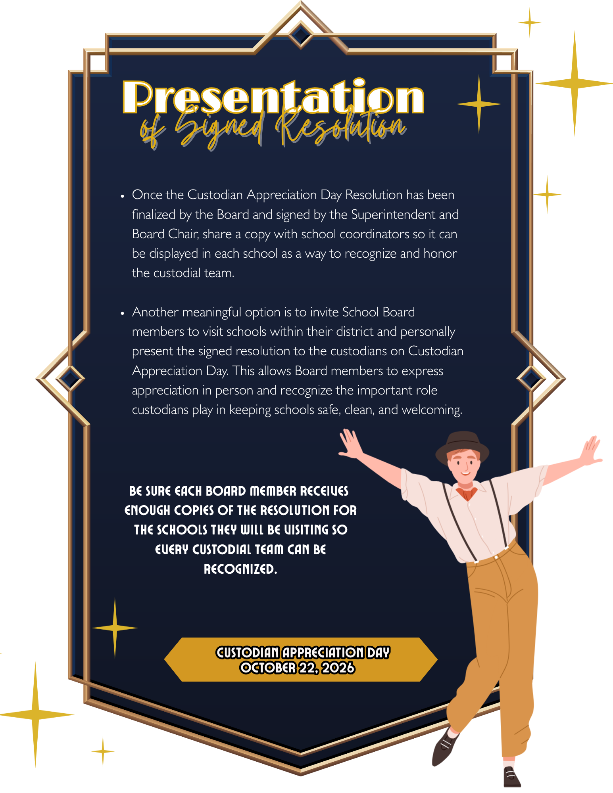

Note: Consider attaching the resolution and a photo of the Board Chair presenting it to a longtime custodian to help encourage local media and social media coverage.
FOR IMMEDIATE RELEASE
DATE: [Insert Current Date]
Next week, students and staff across the __________ School System will come together to celebrate Custodian Appreciation Day, recognized by a resolution from the School Board designating _________ [Insert Date] as a day to honor the dedicated custodial teams who help keep schools safe, clean, and welcoming for everyone.
This year’s celebration is part of the district’s “Appreciation Through the Eras” initiative, featuring a 1920s theme inspired by the spirit and energy of the Roaring ’20s. Schools will highlight the hardworking custodians who keep campuses running smoothly, while students celebrate in fun and creative ways that reflect the style and charm of the era.
Throughout the week, students will recognize custodians with themed decorations, appreciation notes, and schoolwide activities that shine a spotlight on the important role these team members play each day. From creative displays to thoughtful messages of gratitude, the celebrations will reflect the pride and care custodians bring to their work.
Student leaders from each school’s A-Team will help coordinate the activities, encouraging students and staff to take part in recognizing the individuals who work behind the scenes to support a positive learning environment.
The Utrust Appreciation Program, which includes eight appreciation days throughout the school year, helps students develop a deeper understanding of gratitude while providing opportunities to practice leadership and service. Through themed celebrations such as “Appreciation Through the Eras,” students learn that every member of a school community plays an important role in its success.
Superintendent ___________________________ shared, “Our custodians are essential to the daily life of our schools. Their dedication and attention to detail ensure that students and staff have safe and welcoming spaces to learn and work. Custodian Appreciation Day allows us to recognize their contributions and thank them for all they do.”

