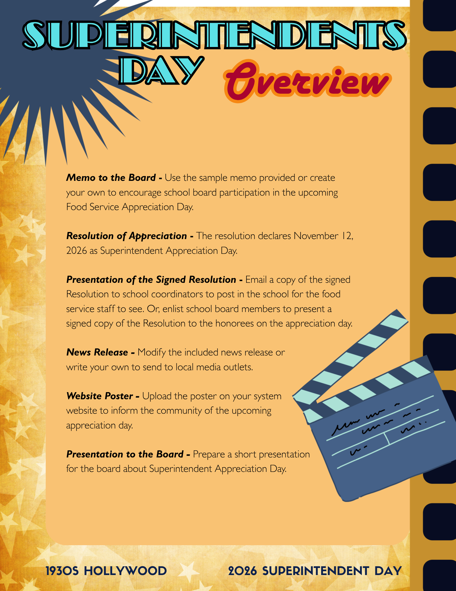


These themed appreciation days not only provide well-deserved recognition for our staff, but also foster positive community engagement and school pride. I encourage each board member to take part in the Hollywood-inspired activities planned across the district, as schools roll out the red carpet to celebrate this special occasion. In addition, each school will participate in a charity drive held in honor of [name] __________.
Let us come together to honor a true “star” of our district—whose leadership continues to guide and inspire with purpose and vision.

To: Board of Education

From: Chairman of the School Board

Re: Superintendent Appreciation Day

Date: November ______, 2026
Each year, through the Utrust Appreciation Program, we take time to spotlight and celebrate the individuals who make a lasting impact on our schools. This November, we turn the spotlight to one of the leading figures in our district—our superintendent.
I propose that we officially declare Thursday, November 12, 2026, as Superintendent Appreciation Day in our school system. This year’s theme—1930s Hollywood—offers a classic and celebratory way to recognize the leadership, vision, and dedication our superintendent brings to the role each day. Like the golden age of cinema, their work reflects excellence, perseverance, and a commitment to creating something truly meaningful for our schools and community.
Enclosed is a Resolution of Appreciation for your review. I recommend that we adopt this resolution to formally recognize our superintendent’s invaluable contributions.


WHEREAS, our Superintendent exemplifies distinguished leadership, guiding the district with integrity, vision, and an unwavering commitment to excellence; and
WHEREAS, with thoughtful planning and responsible stewardship, our Superintendent ensures that resources are allocated effectively to support high-quality teaching and learning across all schools; and
WHEREAS, much like the enduring legacy of the 1930s Hollywood era, our Superintendent’s leadership reflects dedication, creativity, and a pursuit of excellence that inspires both staff and students to achieve their highest potential; and
WHEREAS, our Superintendent champions programs and initiatives that promote academic success, personal growth, and meaningful connections between schools and the community;
NOW, THEREFORE, BE IT RESOLVED, that the Board of Education formally recognizes the outstanding service of ______________ to the students and staff of ______________ Schools and expresses its sincere appreciation for his/her leadership in fostering a positive and enriching educational environment;

BE IT FURTHER RESOLVED, that the ______________ Board of Education hereby proclaims November 12, 2026, as Superintendent Appreciation Day in ______________ Schools;
BE IT FURTHER RESOLVED, that all school principals are encouraged to implement the Utrust Appreciation Program in their schools throughout this month by recognizing the superintendent in meaningful, creative, and Hollywood-inspired ways.



FOR IMMEDIATE RELEASE
DATE: _______________

The ______________ School Board recently adopted a Resolution declaring Saturday, November 12, 2026, as Superintendent Appreciation Day. To celebrate, students and staff across the district will honor Superintendent _______________ with a classic and engaging 1930s Hollywood theme.
Schools throughout the system are planning a variety of activities to recognize the leadership and dedication of their superintendent. One major effort includes a district-wide charity drive to benefit local families in need—a tribute to the Superintendent’s ongoing commitment to service and community. Student leaders from each school’s A-Team will take the lead in organizing appreciation efforts and encouraging widespread participation.
“Great leaders, like the stars of Hollywood’s golden age, leave a lasting impression,” said Board Chairman _______________. “Superintendent _______________ has demonstrated exceptional leadership, vision, and dedication to our schools. We are proud to recognize their contributions and invite everyone to take part in this celebration.”

This event is part of the Utrust Appreciation Program, which designates eight special days throughout the school year to recognize the outstanding work of school employees. The program not only honors staff but also helps students understand the importance of gratitude and service. Superintendent Appreciation Day marks the third celebration of the year.
While students are at the heart of the day’s events, community members are encouraged to join in as well. Whether it’s a note of appreciation, a kind word, or a gesture of thanks, every act of recognition helps shine a well-deserved spotlight on our superintendent.

(Note: Be sure to include a copy of the signed Resolution and a photo of the Board Chair presenting it to the Superintendent. Sharing these with local media and social platforms can help increase visibility and celebration of the event.)





