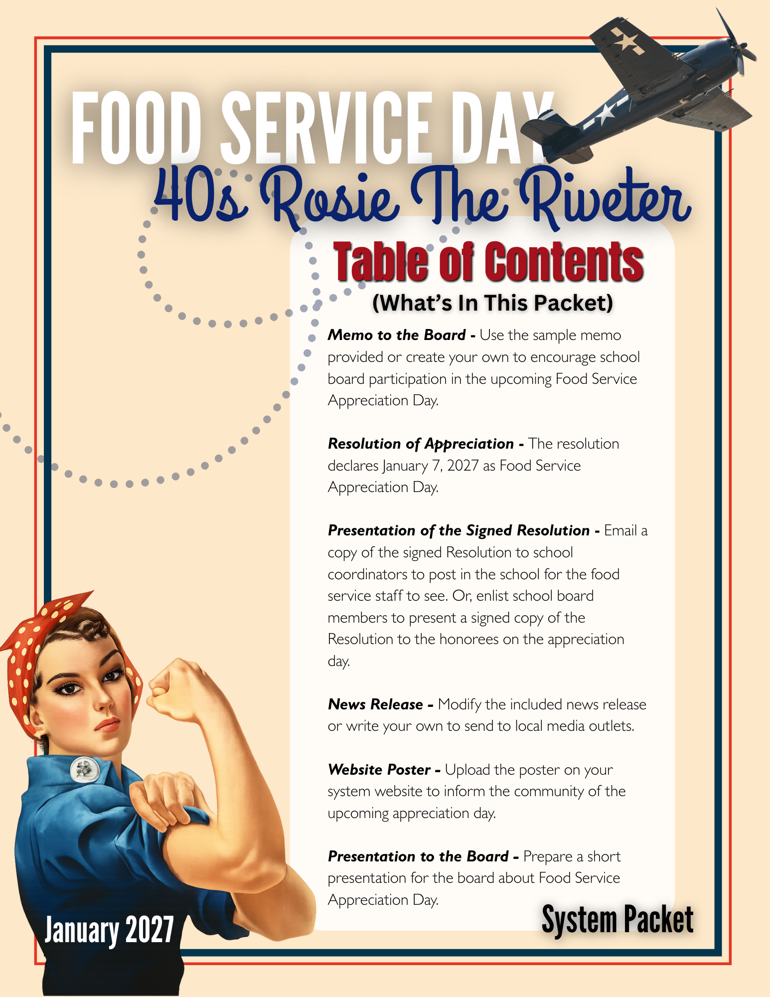

I encourage Board members to participate in the celebration by sending personal notes of appreciation or delivering a signed copy of the resolution to Food Service Workers in each school. Your presence and support would mean a great deal on their special day.

engage in meaningful activities that honor these essential staff members.
Attached is the proposed Resolution for the Board’s approval.

this classic and empowering theme to help students creatively express their gratitude. From patriotic thank-you notes to “We Appreciate You!” posters and messages of recognition, students will

resilience, and “We Can Do It!” determination. Schools will use this

This year’s appreciation theme will be Rosie the Riveter, celebrating the spirit of teamwork, resilience, and “We Can Do It!” determination. Schools will use this classic and empowering theme to help students creatively express their gratitude. From patriotic thank-you notes to “We Appreciate You!” posters and messages of recognition, students will engage in meaningful activities that honor these essential staff members.
This year’s appreciation theme will be Rosie the Riveter celebrating the spirit of teamwork, resilience
TO: Board of Education

FROM: Superintendent

RE: Food Service Appreciation Day

DATE: January ___, 2027
As part of the Utrust Appreciation Program, I recommend that the Board designate January 7, 2027, as Food Service Appreciation Day in the ______________ School District. This day will be set aside to celebrate and recognize the invaluable contributions of our Food Service Staff in each of our schools. The accompanying resolution encourages student participation in a variety of appreciation activities.
Our Food Service team plays a critical role in the daily operation of our schools. Like the hardworking heroes of the 1940s, they show dedication, strength, and commitment every day by providing nutritious, well-prepared meals that support both student wellness and academic success.



Note: Please feel free to change the Resolution as needed as you consider adopting it.
Approved by the _____________________ Board of Education
in regular session on ____________________, 2027.

________________________ ____________________________
Superintendent Board Chairman

WHEREAS, the Food Service Workers in our school system play a vital role in nurturing students by WHEREAS, the Food Service Professionals of our school district make a lasting impact on students by providing nourishing meals that support both learning and overall wellbeing; and
WHEREAS, these committed individuals begin their work each day with dedication and purpose, preparing meals that help students and staff start their day ready to succeed; and
WHEREAS, beyond their daily responsibilities, Food Service Staff foster a positive and welcoming atmosphere, offering encouragement and care to every student they serve; and
WHEREAS, their dependable service, strong work ethic, and teamwork reflect a spirit of perseverance and pride in their contributions to our schools; and
WHEREAS, their efforts are essential to the smooth operation of our schools and play an important role in supporting a healthy and productive learning environment; and
WHEREAS, Food Service Professionals work alongside educators and staff to strengthen the overall mission of our schools by promoting student success and wellness; and
WHEREAS, the Superintendent and the Board of Education of ____________ Schools wish to recognize and honor the meaningful contributions of these valued team members;
NOW, THEREFORE, BE IT RESOLVED that this Board expresses its appreciation for the dedication, reliability, and care demonstrated by our Food Service Professionals; and
BE IT FURTHER RESOLVED that January 7, 2027, be designated as Food Service Appreciation Day in all __________________ Schools.

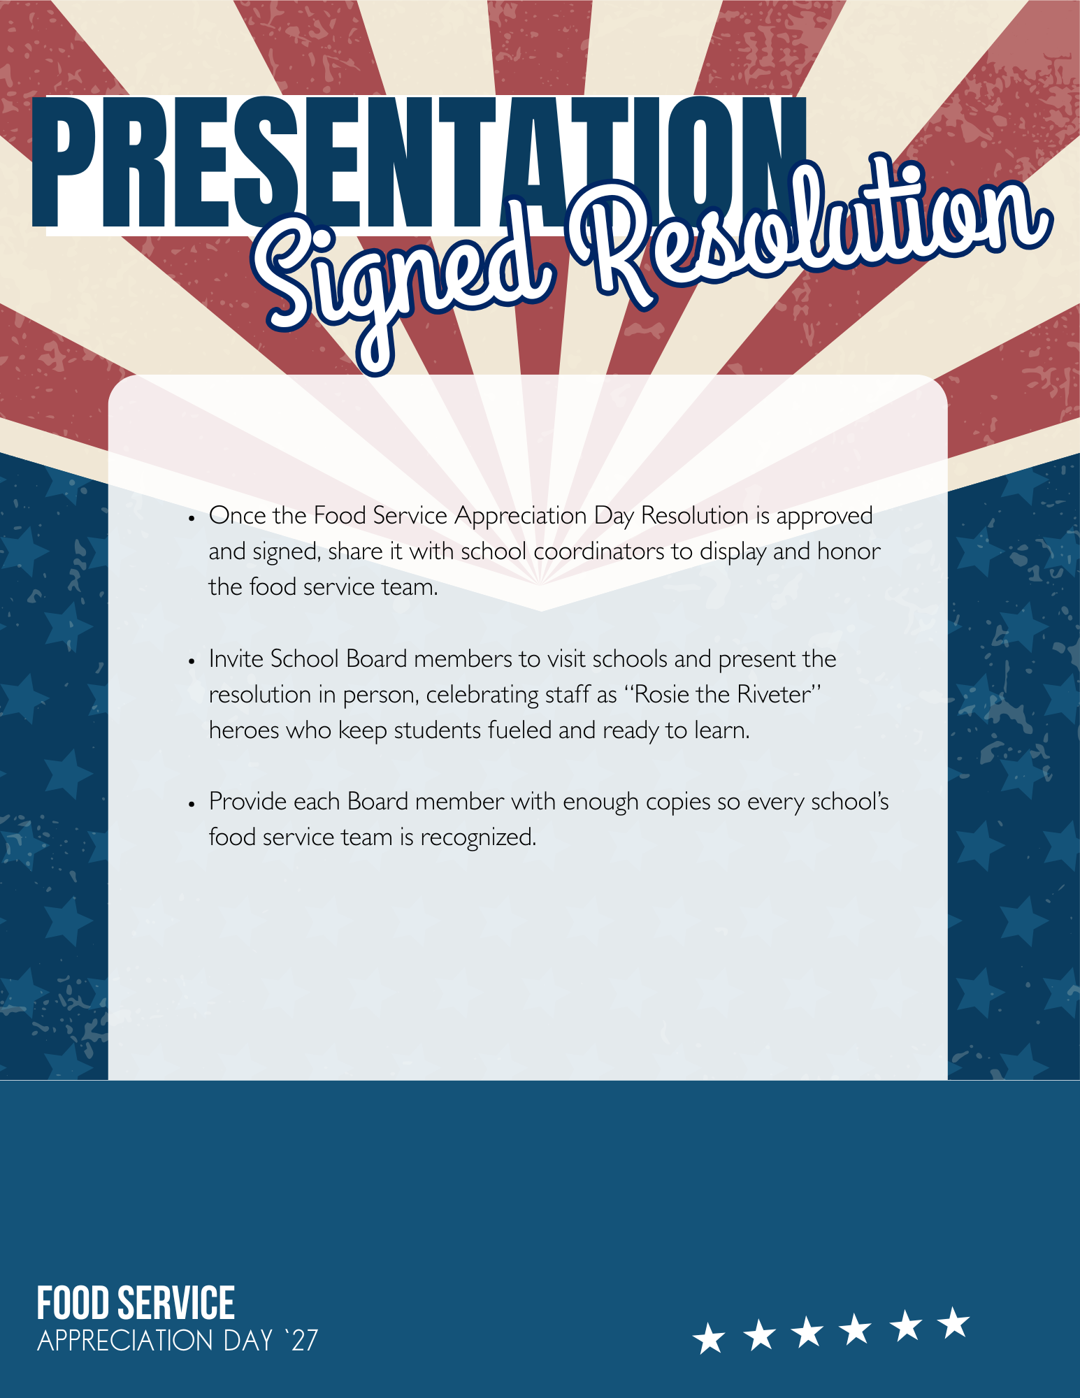

Note: You might want to attach a copy of the resolution and a photo of the chair presenting it to the Food Service Worker with the most years of service. This will help to increase the likelihood that the local newspaper will run the story and be picked up by social media.

FOR IMMEDIATE RELEASE
Date ________________
January 7, 2027 – Students across [SCHOOL DISTRICT NAME] are gearing up to celebrate Food Service Appreciation Day with a spirited tribute inspired by the strength, determination, and pride of the 1940s. Each school’s A-Team will lead the charge with engaging, Rosie the Riveter-themed activities designed to recognize the hardworking individuals who keep students nourished and ready to succeed each day.
Superintendent [SUPERINTENDENT'S NAME] shared his/her enthusiasm for the celebration:
"Our food service professionals embody the same grit and dedication we associate with the ‘We Can Do It!’ spirit. Day in and day out, they show up ready to serve, making a meaningful difference in the lives of our students. This celebration is a chance for us to come together, show our appreciation, and recognize the pride they take in their work."
As part of the Utrust Appreciation Program (UAP), Food Service Appreciation Day empowers students to take the lead in recognizing the contributions of school staff. This year’s 1940s-inspired theme highlights the values of teamwork, resilience, and commitment—qualities our food service teams demonstrate every single day.
On January 7, whether in the cafeteria or out in the community, take a moment to thank a food service worker with a heartfelt message of appreciation. Your recognition helps honor these dedicated individuals who play an essential role in keeping our schools strong and thriving.


