


TO: Board of Education
FROM: Superintendent
RE: Principal Appreciation Day
DATE: February __________, 2027
The next appreciation day in the Utrust Appreciation Program is Principal Appreciation Day, scheduled for Thursday, February 4, 2027. This year’s theme is Appreciation Through the Eras: 1950s Edition, celebrating a decade known for strong community values, optimism, and school pride—qualities our principals and assistant principals exemplify every day.
Attached is the Resolution of Appreciation. Please consider adopting it to honor this exceptional group of leaders in our school system.
Through the 1950s edition theme, we aim to highlight the timeless nature of effective leadership. While fashions and decades may change, dedication, integrity, and commitment to student success never go out of style. Our principals and assistant principals meet daily challenges with resilience and vision, creating supportive learning environments where students and staff can thrive.
Please join me in supporting and participating in the Utrust Appreciation Program. We look forward to a meaningful celebration as we express our heartfelt appreciation to our principals and assistant principals for their leadership and lasting impact on our schools.


WHEREAS, principals and assistant principals play a vital role in shaping the educational experience by serving as leaders, mentors, evaluators, and problem solvers; and
WHEREAS, they provide steady leadership and guidance to students, faculty, and staff, promoting a positive and productive school culture; and
WHEREAS, our principals and assistant principals set clear goals for school success and work tirelessly to implement plans that benefit both academic and personal growth; and
WHEREAS, they foster safe, supportive, and engaging learning environments where every student has the opportunity to thrive; and
WHEREAS, as part of this year’s “Appreciation Through the Eras: 1950s Edition” celebration, we recognize that while styles and decades may change, strong leadership, integrity, and commitment remain timeless qualities demonstrated daily by our school administrators; and
WHEREAS, their resilience, professionalism, and dedication are essential to the daily operations and long-term success of our schools;
NOW, THEREFORE, BE IT RESOLVED that the _______________ Board of Education hereby designates February 4, 2027, as Principal Appreciation Day in all schools across the district; and
BE IT FURTHER RESOLVED that the Board extends its heartfelt appreciation to the principals and assistant principals for their unwavering dedication and encourages students, staff, and the community to join in recognizing and celebrating their leadership and service during this special “Appreciation Through the Eras” observance.
Approved by the _______________ Board of Education in regular session on _______________, 2027.
_________________________ ____________________________
Superintendent Board Chairman

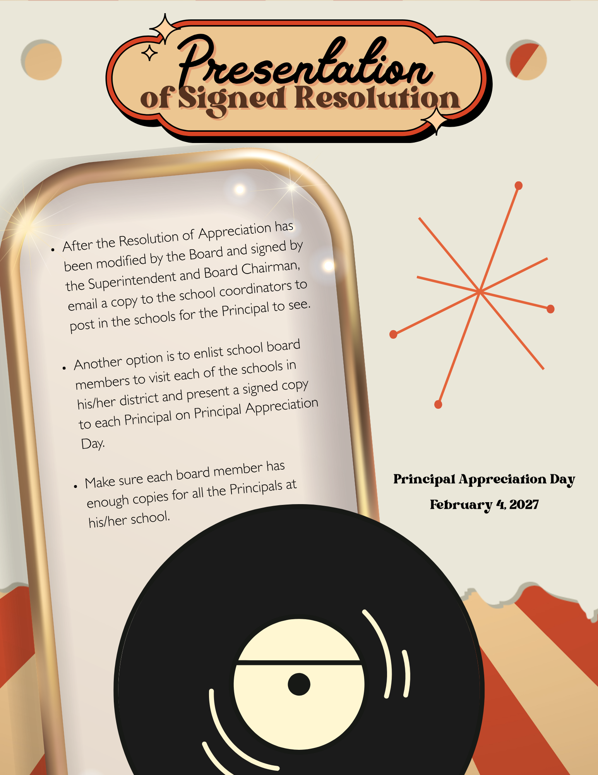

Note: Consider attaching the resolution and a photo of the Board Chair presenting it to a veteran principal to help encourage local media and social media coverage.

FOR IMMEDIATE RELEASE
DATE: [Insert Current Date]
Next week, students and staff in the __________ School System will come together to celebrate Principal Appreciation Day, officially recognized by a resolution from the School Board designating February 4, 2027, as a day to honor school leadership.
This year’s celebration is part of the district’s “Appreciation Through the Eras” initiative, with a spotlight on the 1950s edition. Inspired by the music, style, and strong sense of community that defined the decade, students will celebrate their principals and assistant principals in true retro fashion—honoring leadership that stands the test of time.
From sock hop–inspired decorations and jukebox-themed appreciation notes to creative “rockin’ leadership” activities, students will highlight the dedication, commitment, and positive influence their school leaders bring to campus each day. Just like the 1950s era was marked by optimism and unity, our principals continue to build school communities grounded in pride, perseverance, and purpose.
Student leaders from each school’s A Team will coordinate the festivities, ensuring that every principal and assistant principal feels recognized and celebrated in classic 1950s style.
The Utrust Appreciation Program, which includes eight appreciation days throughout the school year, is designed to teach students the value of gratitude while providing meaningful leadership opportunities. Through themed celebrations like “Appreciation Through the Eras,” students learn that while times may change, appreciation never goes out of style.
Superintendent ___________________________ shared, “We are fortunate to have outstanding principals in the __________ School System. Their leadership continues to shape the future of our schools, and this celebration gives us the opportunity to honor their dedication and lasting impact.”





