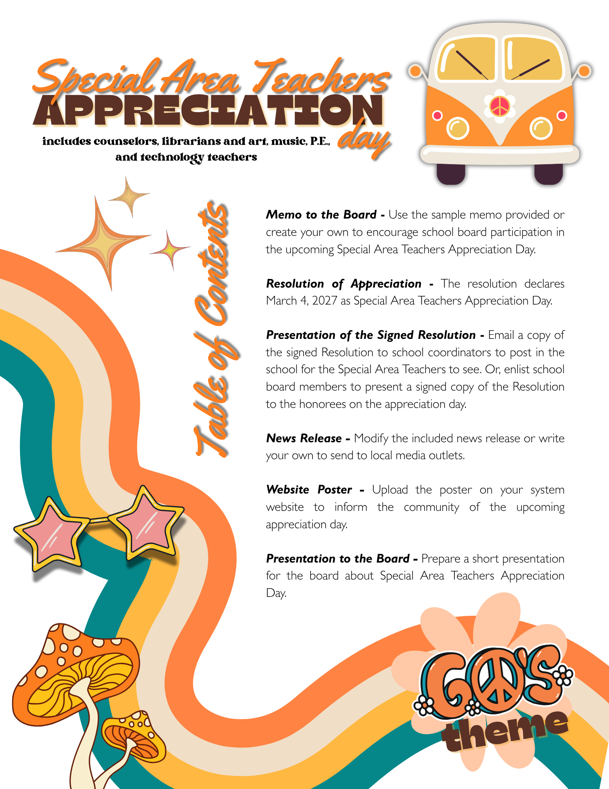


To: Board of Education

From: Superintendent

Re: Special Area Teachers Appreciation Day

Date: March __, 2027
We are excited to announce that March 4, 2027, has been designated as Special Area Teachers Appreciation Day by Utrust. This special day is devoted to recognizing the vital work of our outstanding art, music, physical education, technology, speech instructors, school counselors, and librarians. (Please omit any categories not applicable to your district.) Their impact on the academic, emotional, and social well-being of our students is significant and worthy of high-level recognition.
This year’s overarching theme is “Appreciation Through the Eras,” with each staff recognition day throughout the year highlighting a different decade. For Special Area Teachers Appreciation Day, we will celebrate with a 1960s Edition, honoring these educators through the creativity, innovation, and cultural spirit that defined the era. Just as the 1960s inspired expression, exploration, and new ways of thinking, our Special Area Teachers empower students every day to discover their talents, embrace creativity, and grow with confidence.
Students will take the lead in spreading appreciation through era-inspired activities, decorations, and messages of gratitude that reflect the music, art, movement, and innovation that defined the 1960s. This celebration provides an engaging and meaningful way to recognize the lasting contributions these educators make in the lives of our students.
Enclosed is the Resolution of Appreciation, which officially establishes Special Area Teachers Appreciation Day. I recommend we adopt this resolution and observe the occasion on March 4, 2027.
I invite you to join me in celebrating these exceptional educators and ensuring they receive the recognition they so richly deserve.

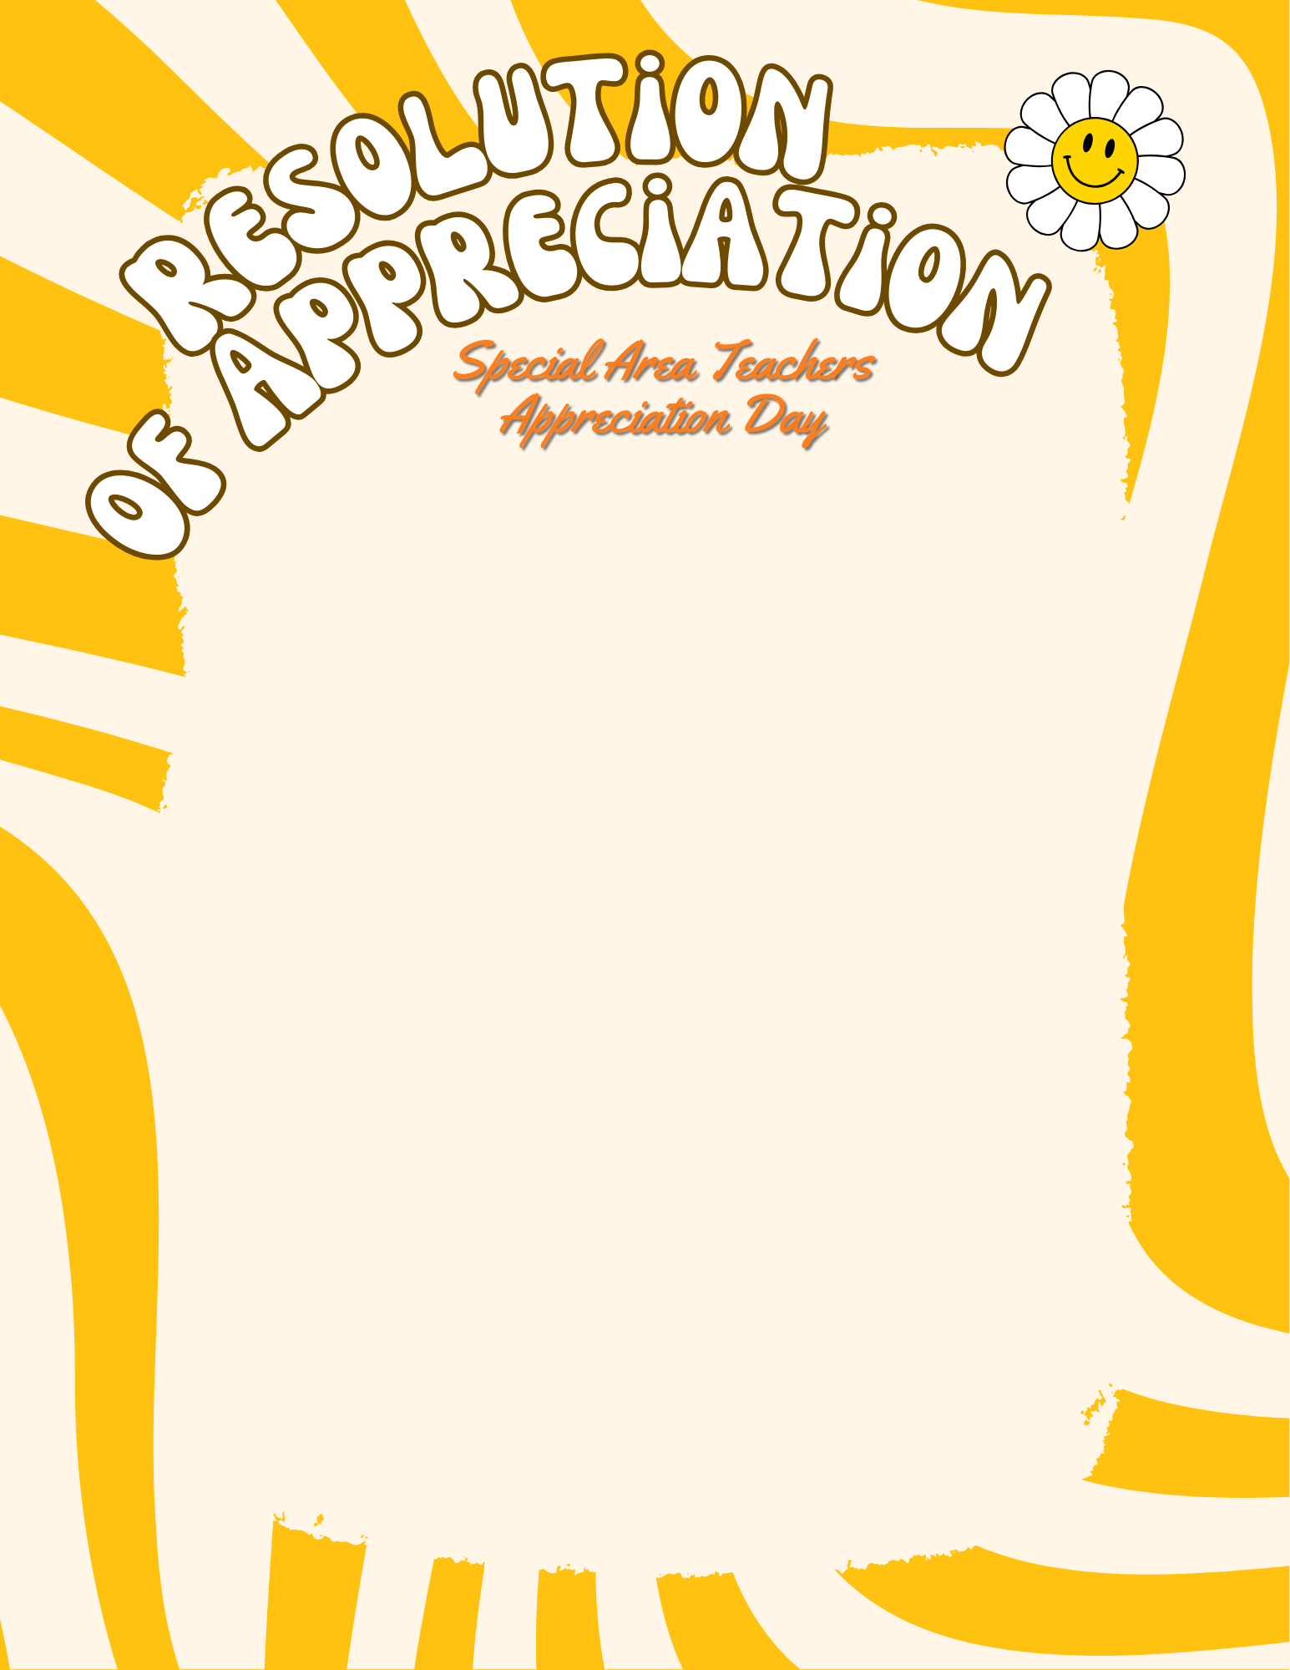
WHEREAS, Special Area Teachers and Staff—including educators in Art, Music, Physical Education, Technology, Speech, School Counseling, Library Media, and other specialized instructional fields—are essential to the mission of the __________ School System, providing students with a comprehensive and enriching educational experience; and
WHEREAS, these dedicated professionals cultivate creativity, inspire innovation, promote wellness, and support the academic and personal growth of every learner; and
WHEREAS, the 1960’s era was a time marked by progress, imagination, cultural expression, and bold new ideas—qualities reflected daily in the work of Special Area Educators who empower students to think creatively, collaborate meaningfully, and explore their unique talents; and
WHEREAS, the __________ Board of Education recognizes the lasting and positive impact these educators and staff members have on students, schools, and the greater community;
NOW, THEREFORE, BE IT RESOLVED that the __________ Board of Education hereby proclaims March 4, 2027, as Special Area Teachers Appreciation Day across all __________ Schools, celebrating the theme “Appreciation Through the Eras: 1960’s Edition,” honoring the vibrant contributions and enduring influence of these exceptional educators; and
BE IT FURTHER RESOLVED that the Board of Education expresses its sincere gratitude to all Special Area Teachers and Staff for their dedication, professionalism, and commitment to fostering excellence and opportunity for every student.
Duly passed and adopted by the __________________________ Board of Education in a regular session on ___________________, 2027.
Note: Please feel free to change the Resolution as needed as you consider adopting it.

_________________________ ____________________________
Superintendent Board Chairman

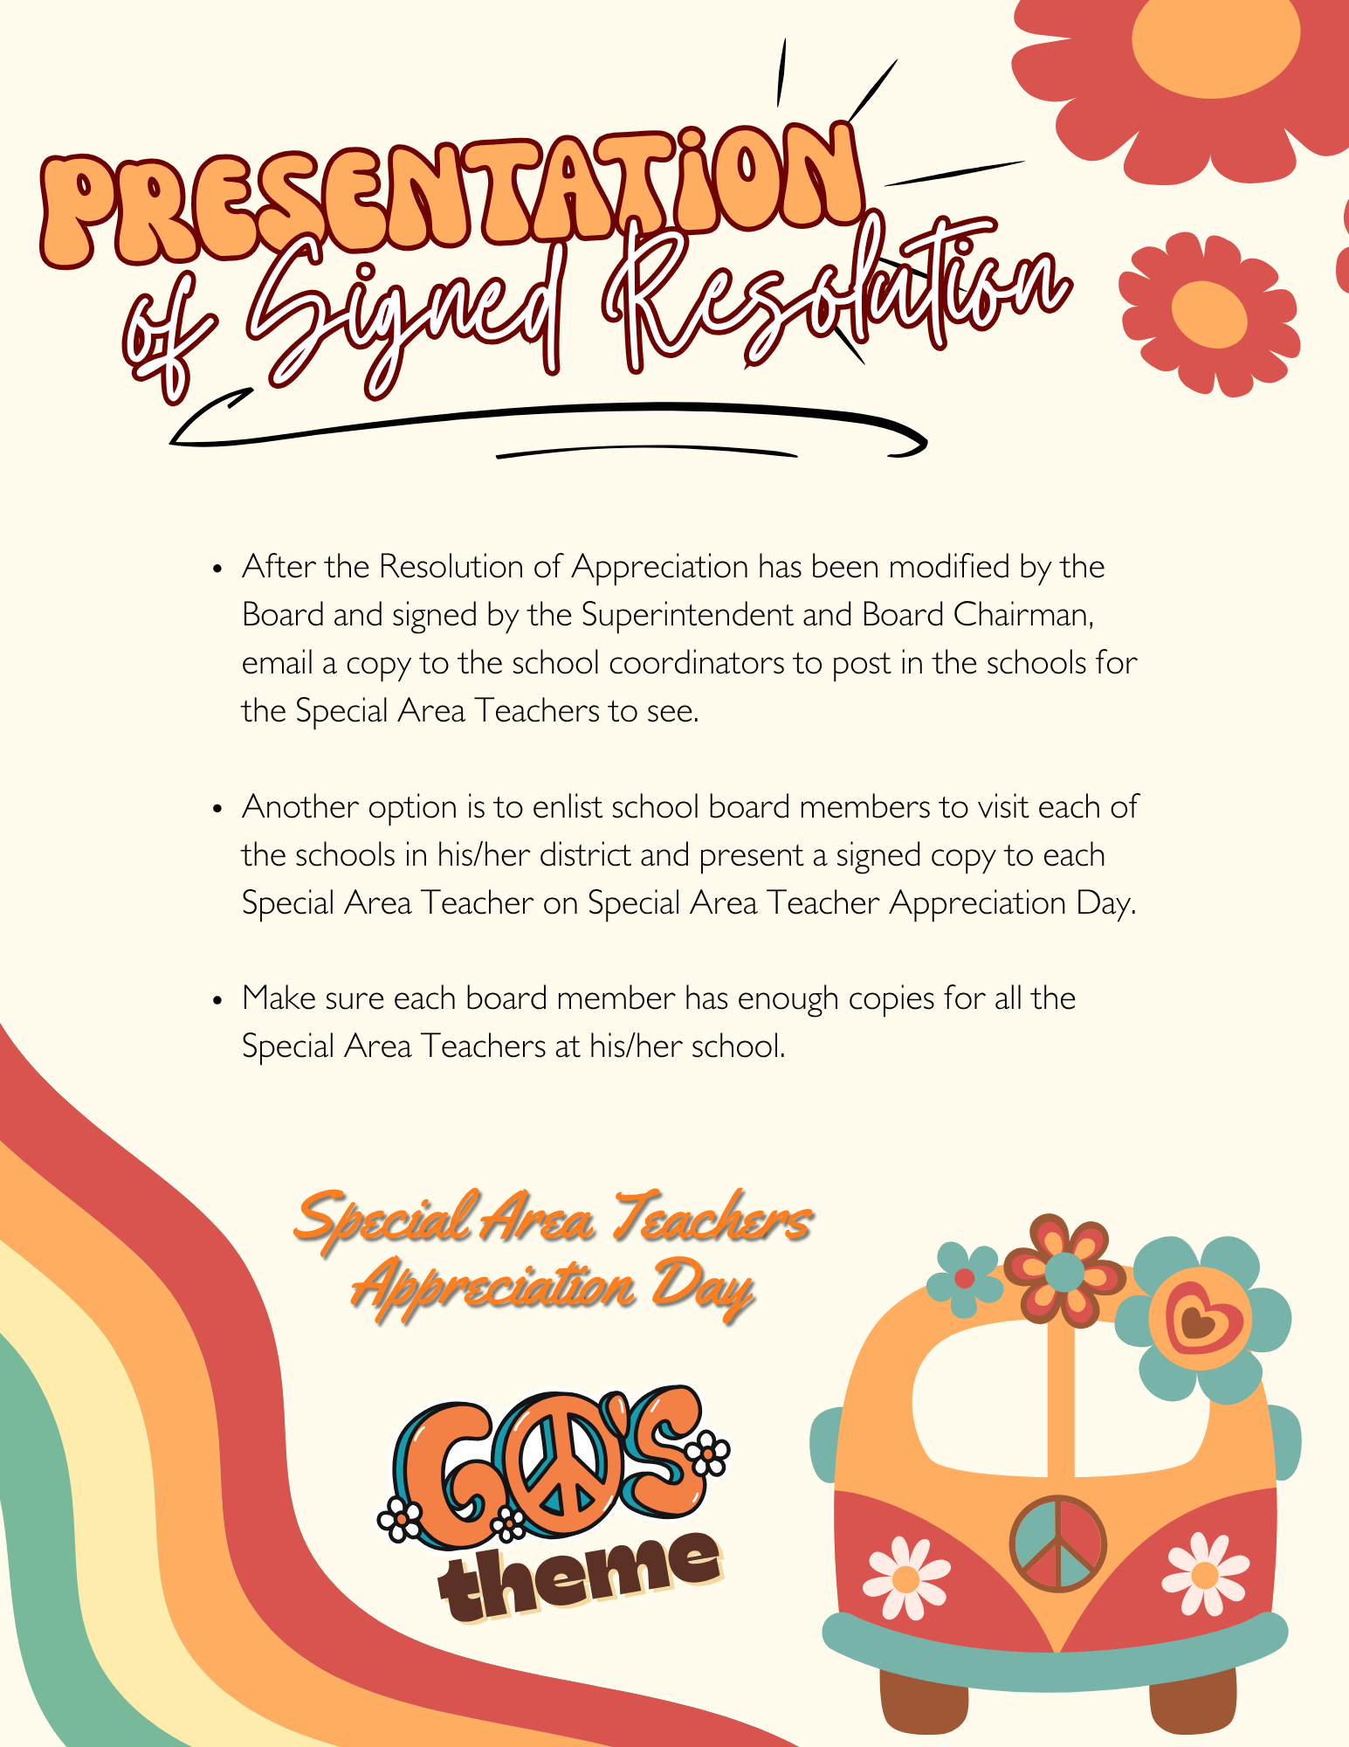

Note: Consider attaching a copy of the resolution and a photo of the chairperson awarding it to a seasoned Special Area Teacher. Such a move can significantly boost the visibility of the event, encouraging local media to spotlight the story and share it across social media platforms.

FOR IMMEDIATE RELEASE
Date ________________

This March, the ________________ School System is turning back the clock to celebrate the vibrant spirit of the 1960’s as it honors its Special Area Teachers. The Board of Education has officially proclaimed March 4, 2027, as Special Area Teachers Appreciation Day, embracing this year’s theme: “Appreciation Through the Eras: 1960’s Edition.”
Inspired by a decade known for creativity, cultural expression, innovation, and bold new ideas, this celebration highlights the powerful influence Special Area Teachers have on students every day.
“Our Special Area Teachers bring energy, imagination, and opportunity into our schools,” said Superintendent ________________________. “From Art and Music to Physical Education, Technology, Speech, Counseling, and Library Services (omit any not applicable), these educators help students discover their talents, express themselves confidently, and build skills that last a lifetime. Their impact is meaningful, lasting, and worthy of celebration.”
Special Area Teachers Appreciation Day is one of eight signature celebrations within the Utrust Appreciation Program (UAP), an initiative designed to recognize outstanding staff members while teaching students the importance of gratitude and encouragement. Through themed activities, student participation, and school-wide recognition efforts, the program fosters a culture where appreciation becomes part of the everyday rhythm of school life.
As schools embrace the colorful energy and optimism of the 1960’s, the district invites students, families, and community members to join in recognizing the educators who inspire creativity, spark curiosity, and help every learner shine.

