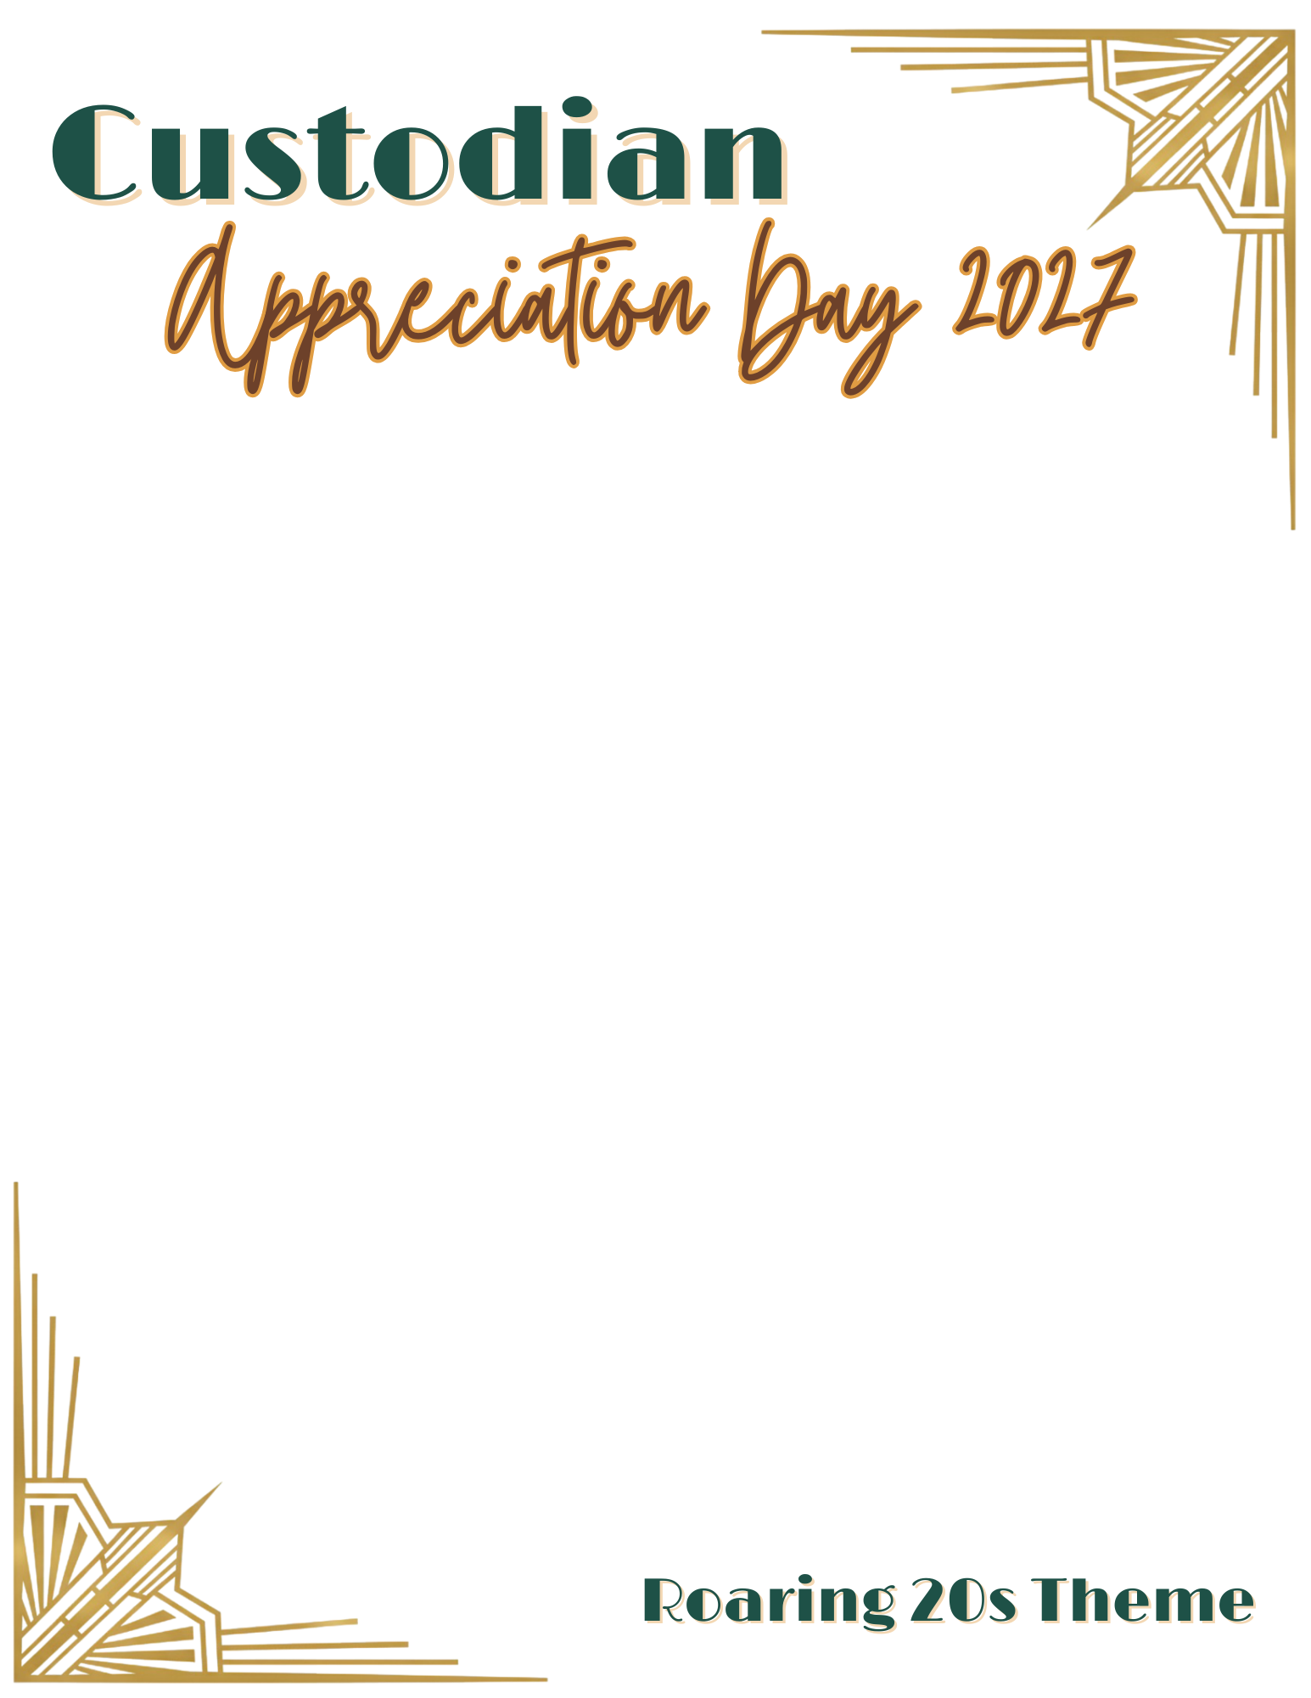

SUBJECT: NOTE FROM THE PRINCIPAL: Custodian Appreciation Day – Supporting Students Every Day
On [day of week], [date], we will celebrate Custodian Appreciation Day. Our custodial staff plays an essential role in keeping our schools safe, clean, and welcoming for students and staff.
As we recognize this important work, we also encourage custodians to take a moment that day to show appreciation to the students you see throughout the building. Small interactions can help students feel noticed and valued.
Be intentional about thinking of ways to recognize students. Here are some ways to consider:
• Say good morning when passing students.
• Use students’ names when you know them.
• Ask the names of students you see often and use them.
• Thank students who clean up after themselves.
• Compliment (maybe leave a note) a class that keeps their space clean.
• Acknowledge student artwork or projects while working nearby.
• Smile and greet students consistently in the same areas.
• Say, “I appreciate you taking care of your school.”
• Tell a student, “I’m glad you’re here today.”

Thank you for everything you do to help create a positive environment for students each day.
Sincerely,
[Principal Name]
[School Name]

