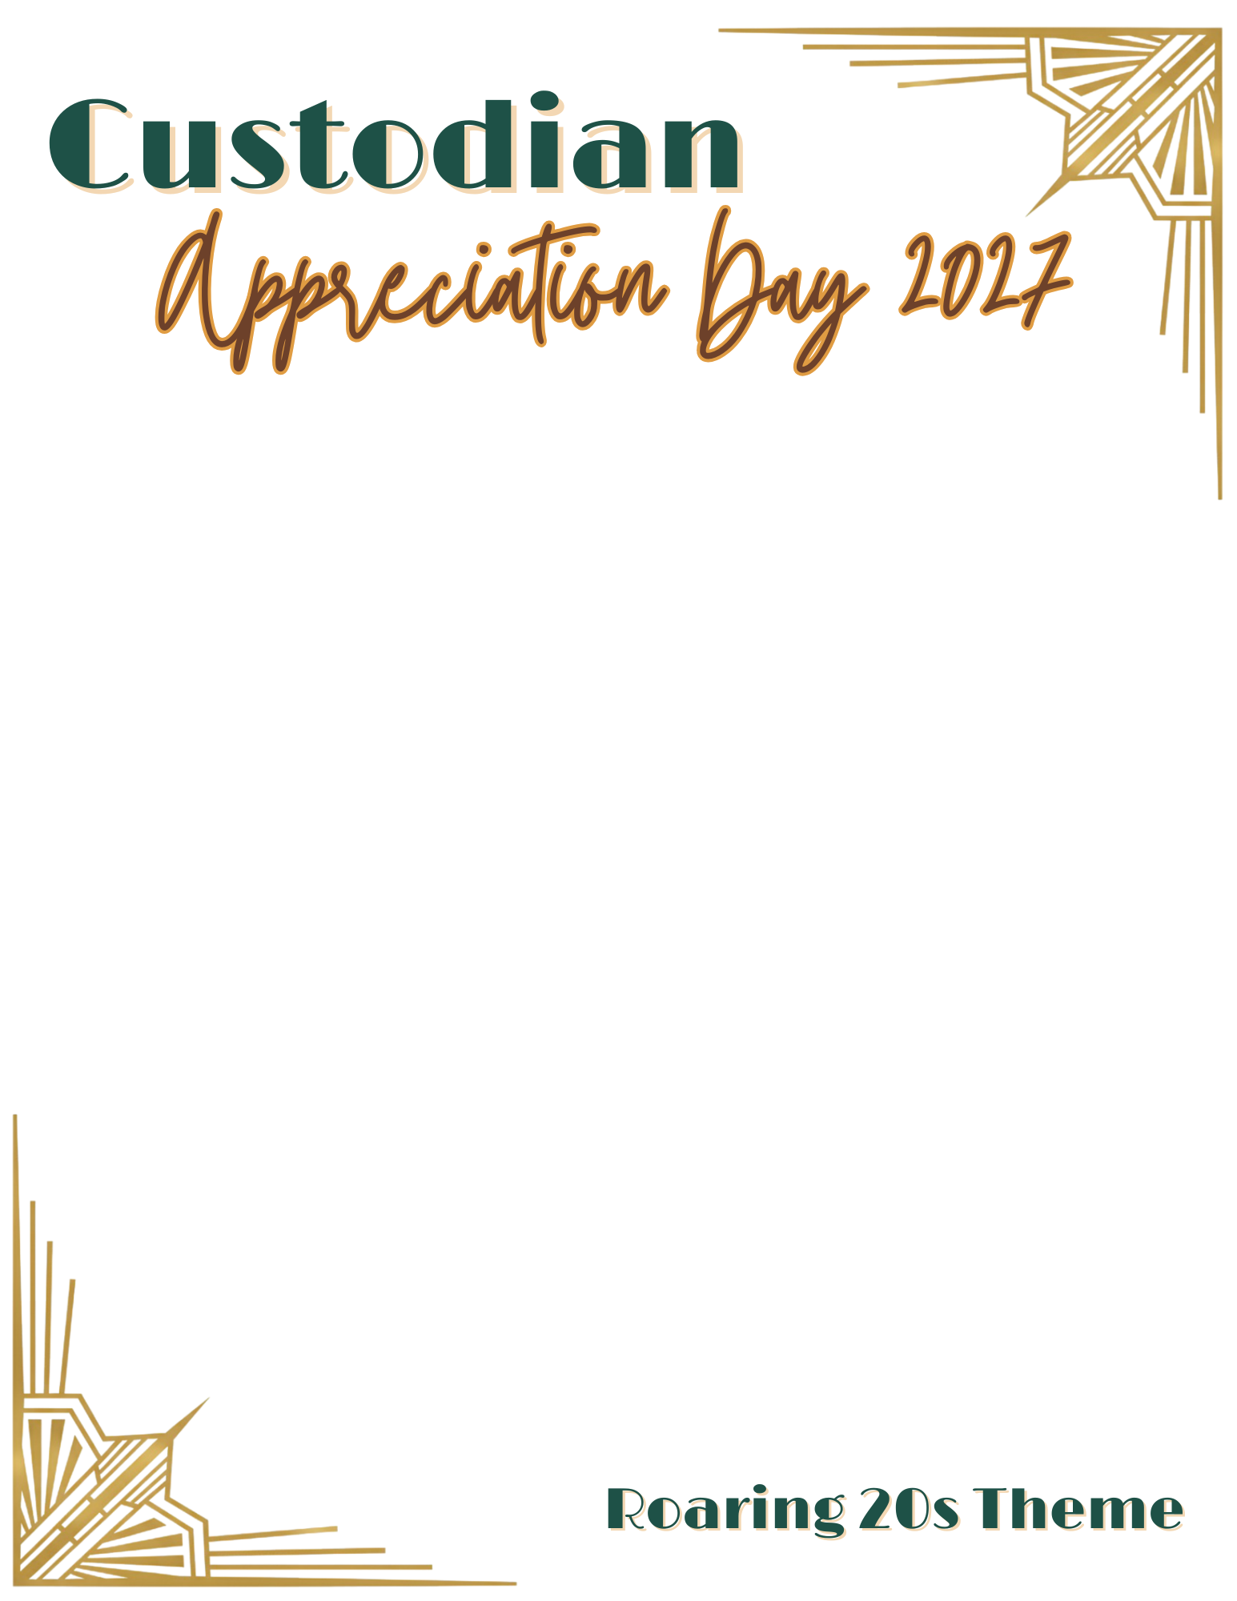

SUBJECT: NOTE FROM THE PRINCIPAL: Custodian Appreciation Day – Help Us Say Thank You!
Hello!
On [day of the week], [date], we will celebrate Custodian Appreciation Day. This year’s celebration will feature a fun Roaring 20’s theme, giving us a chance to show our gratitude with a little vintage flair while recognizing the hardworking individuals who help keep our school running smoothly.
Our custodians play an essential role in our school community. Their dedication, care, and behind-the-scenes work help keep our building clean, safe, and welcoming for students and staff every day. From early mornings to late afternoons, their efforts make a real difference in creating a positive learning environment.
If you would like to participate, we’ve included a few simple ways families can show appreciation. Participation is completely optional, but even a small gesture can mean a lot.
Ways families can show appreciation for our custodians:
- Send a note or email thanking them for keeping the school clean and safe.
- Share positive feedback with the principal about the care they take in maintaining the building.
- Give a thank-you card or individually wrapped treats.
Thank you for helping us recognize and celebrate the people who support our students every day. We are grateful for the dedication our custodial team shows to our school community.
Sincerely,
[Principal Name]
[School Name]

