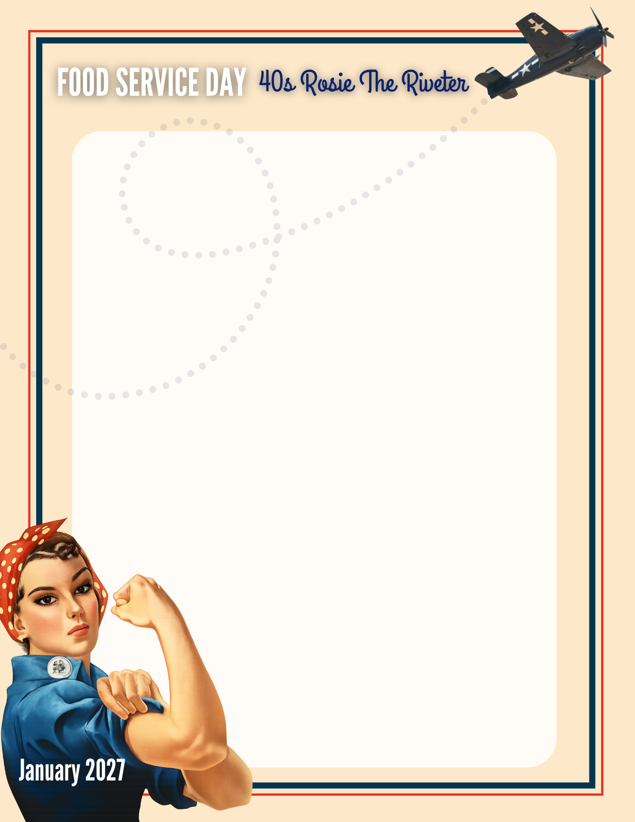

SUBJECT: NOTE FROM THE PRINCIPAL: Food Service Appreciation Day – Encouraging Students Each Day
On [day of week], [date], we will celebrate Food Service Appreciation Day. Our food service staff play an important role in making sure students are nourished and welcomed each day.
As we celebrate your work, we also encourage you to take a moment that day to show appreciation to the students you serve. Even small interactions can brighten a student’s day.
Be intentional about thinking of ways to recognize students. Here are some ways to consider:
• Greet students warmly in the line.
• Use students’ names when you know them.
• Ask regulars their names and use them.
• Make eye contact and say “You’re welcome.”
• Compliment polite behavior.
• Offer encouragement on tough days.
• Make small positive comments (“Great choice!”)
• Thank students for their patience during busy times.
• Send them off with, “Enjoy your day.”
Thank you for the care and kindness you show students every day.

Sincerely,
[Principal Name]
[School Name]

