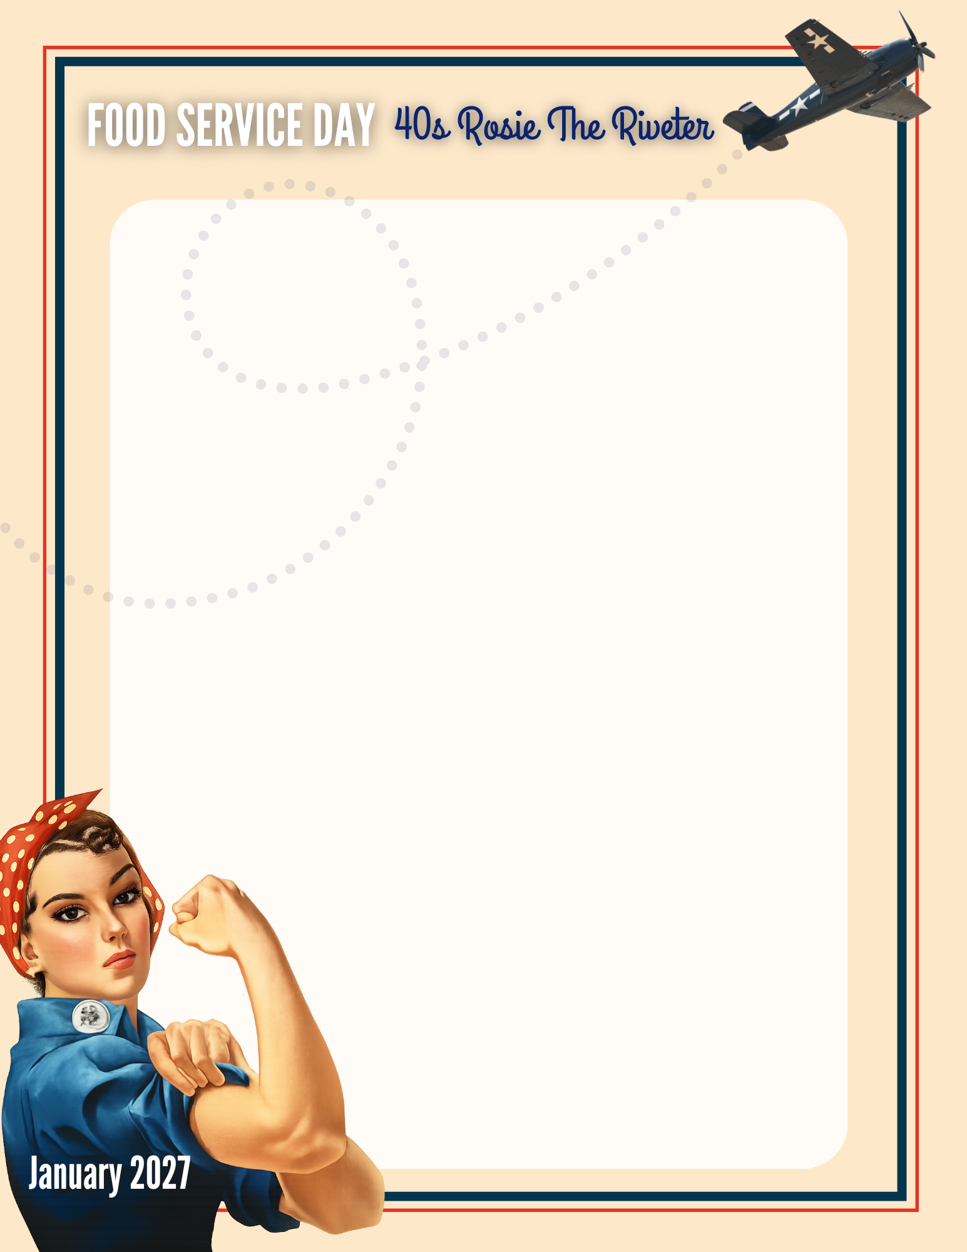

SUBJECT: NOTE FROM THE PRINCIPAL: Food Service Appreciation Day – Help Us Say Thank You!
Hello!
On [day of the week], [date], we will celebrate Food Service Appreciation Day. This year, we are adding a fun 1940s-Rosie the Riveter theme as we recognize the wonderful team members who help nourish our students each day.
Our food service staff play an important role in our school community. Through their dedication, care, and hard work—often behind the scenes—they ensure students have access to nutritious meals in a welcoming environment. Their efforts help students stay energized and ready to learn, and we are grateful for all they do.
If you would like to participate, we’ve included a few simple ways families can show appreciation. Participation is completely optional, but even a small gesture can mean a lot.
Ways families can show appreciation for our food service staff:
- Send a note or email thanking them for preparing meals for students each day.
- Share positive feedback with the school recognizing their friendliness or efficiency.
- Give a thank-you note or a small basket of snacks.
Thank you for helping us recognize and celebrate the people who support our students every day. We truly appreciate the dedication of our food service team and the difference they make in our school community.
Sincerely,
[Principal Name]
[School Name]

