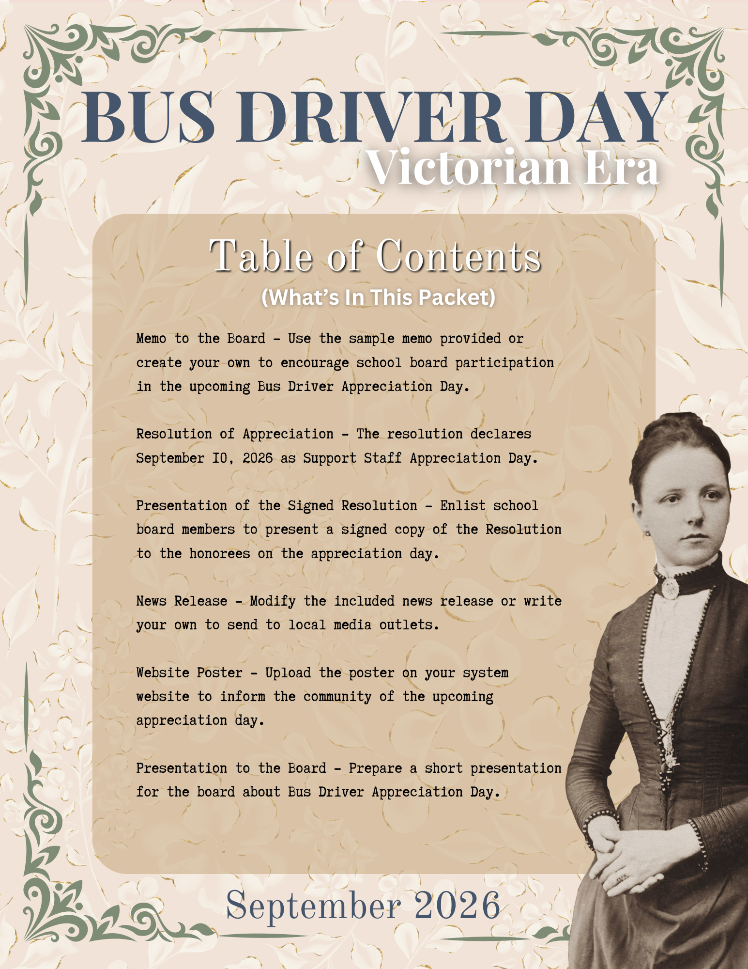

TO: Board of Education

FROM: Superintendent

RE: Bus Driver Appreciation Day

DATE: September ___, 2026
Utrust has declared September 10, 2026, as Bus Driver Appreciation Day, and this year’s celebration embraces the elegance and spirit of the Victorian era.
Attached to this memo is the Resolution of Appreciation officially designating September 10, 2026, as Bus Driver Appreciation Day in our district. I encourage you to adopt the resolution and support this meaningful recognition.
Our bus drivers are the steadfast stewards of each school day’s journey. Much like the devoted professionals of the Victorian age—known for their discipline, reliability, and commitment to duty—our drivers ensure that every student is transported safely and punctually, morning and afternoon. Their watchful care, composure, and sense of responsibility reflect the highest standards of service.
This year’s Victorian theme offers students a refined and thoughtful way to express their gratitude. Through acts of appreciation inspired by an era that valued courtesy and respect, students will honor the dedication and dependability of our bus drivers, whose daily contributions often go unseen but never unnoticed.
We are proud to continue our participation in the Utrust Appreciation Program, which strengthens school culture and instills in students the enduring value of gratitude and respect for others.
Please join me in recognizing and celebrating our bus drivers—true professionals whose commitment ensures the safe passage of our students each and every day.


_______________________ _______________________
Superintendent Board Chairman
WHEREAS, school bus drivers serve as dependable guardians of student transportation, ensuring that each journey to and from school is conducted with the utmost care and precision; and
WHEREAS, their daily presence offers more than transportation, as they provide a reassuring start and close to the school day through patience, courtesy, and quiet encouragement; and
WHEREAS, in the tradition of the Victorian era—where duty, decorum, and reliability were held in the highest regard—our bus drivers exemplify these same enduring values through their professionalism and commitment; and
WHEREAS, they skillfully manage demanding schedules, diverse routes, and ever-changing conditions, demonstrating composure and sound judgment in all circumstances; and
WHEREAS, their vigilance and preparedness contribute significantly to the safety and well-being of every student entrusted to their care; and
WHEREAS, they continually refine their skills through training and adherence to best practices, ensuring that our transportation system remains both safe and efficient; and
WHEREAS, the Superintendent and Board of Education wish to formally recognize the dignity, dedication, and essential contributions of these valued members of our school community;
NOW, THEREFORE, BE IT RESOLVED, that the ______________ Board of Education hereby proclaims September 10, 2026, as Bus Driver Appreciation Day in ______________ Schools; and
BE IT FURTHER RESOLVED, that all students, staff, and families are encouraged to express their gratitude and appreciation for our bus drivers, whose steadfast service and courteous spirit make a lasting difference in the lives of those they serve.
Approved by the _____________ Board of Education in regular session on _____________.

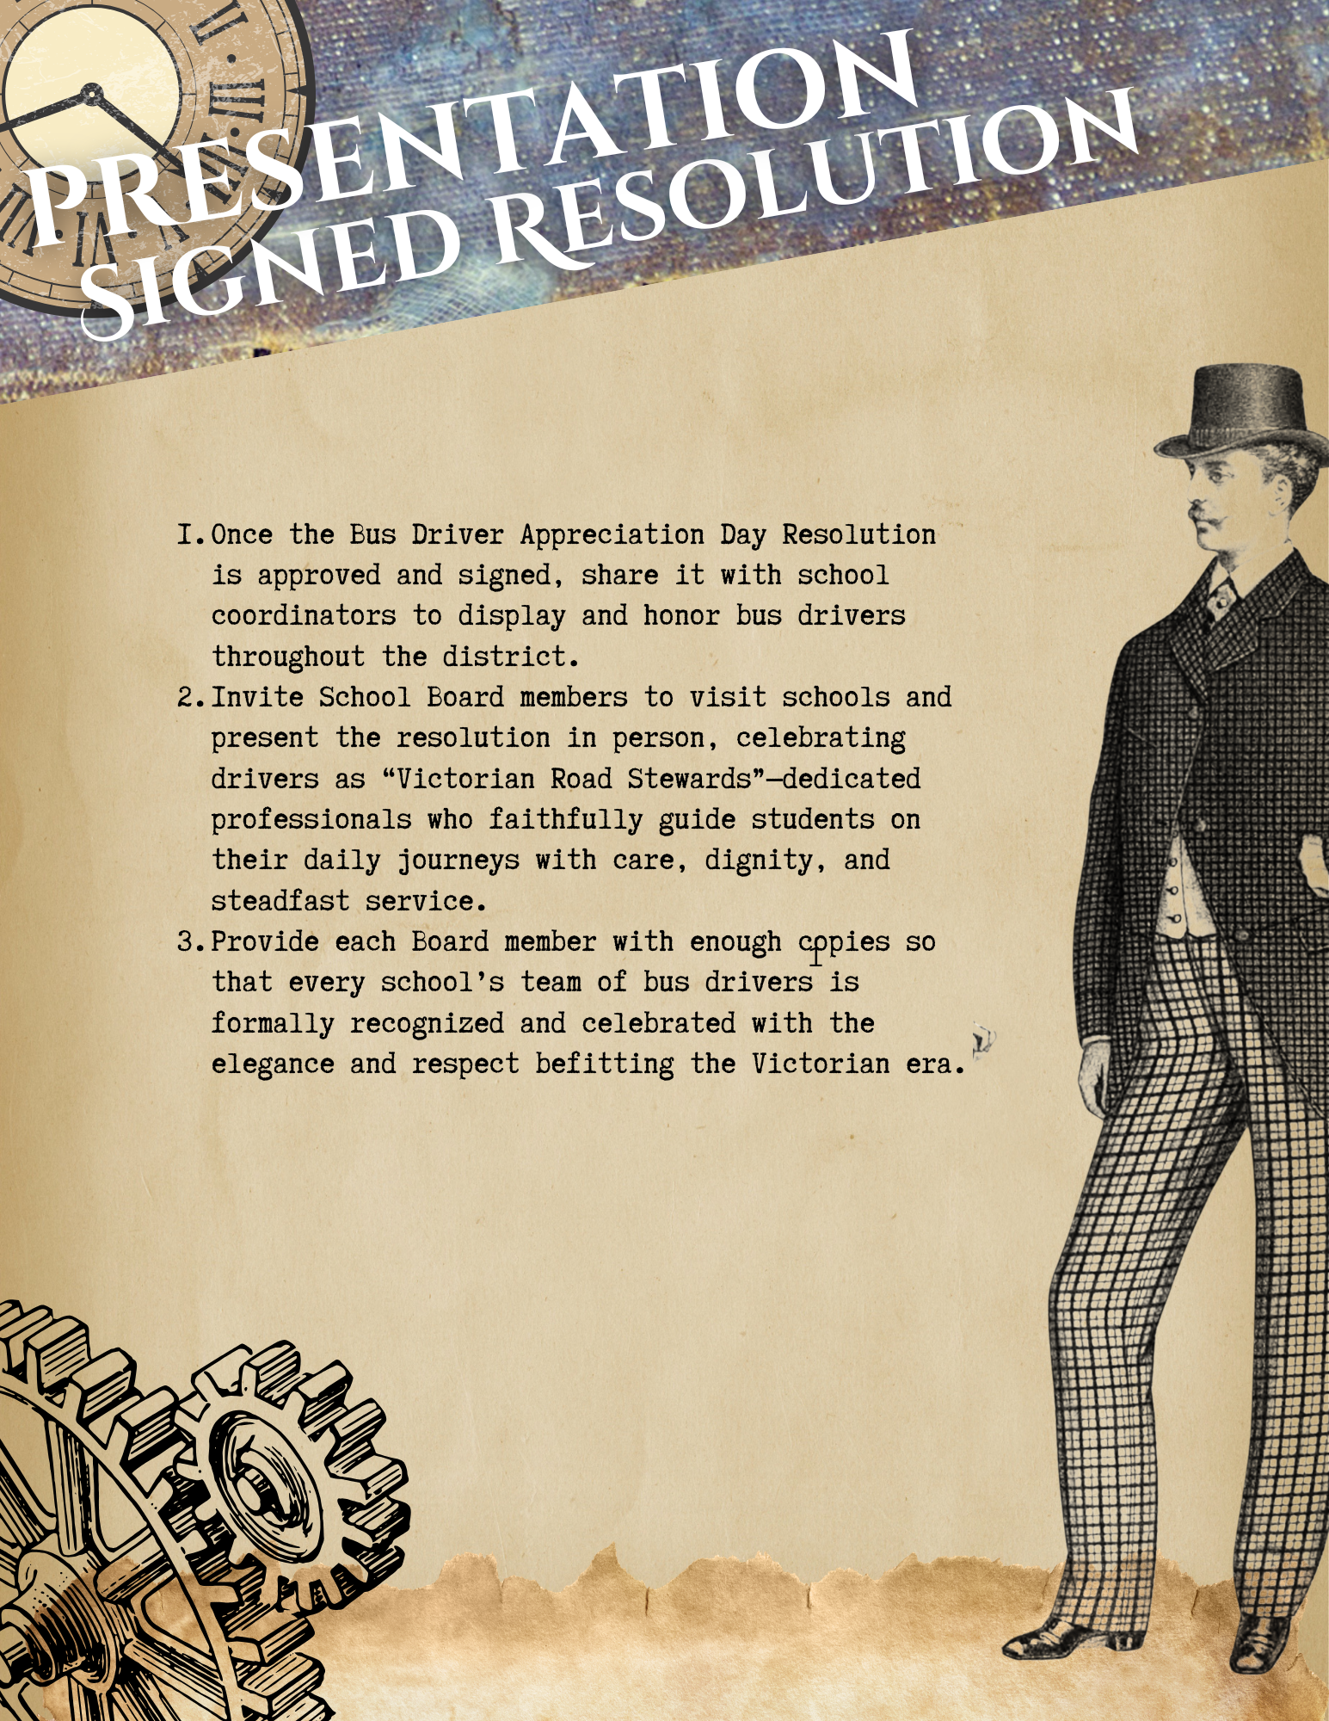

FOR IMMEDIATE RELEASE
Date ___________________

The ______________ School Board has officially declared September 10, 2026, as Bus Driver Appreciation Day in the _________________ School System. This year’s celebration embraces a distinguished Victorian-era theme as students, staff, and the community come together to honor the dedicated professionals who ensure safe and reliable transportation for our students each day.
“Our bus drivers represent the highest standards of service and dependability,” said _________________, Board Chairman. “With a sense of duty and care reminiscent of the Victorian era, they carry out their responsibilities with precision and pride, ensuring that every student’s journey begins and ends safely.”
Director of Schools, _________________, added, “Bus drivers are often the first and last point of connection for our students each day. Their kindness, consistency, and professionalism help set a positive tone that carries throughout the school day. We are honored to recognize their contributions in a meaningful and memorable way.”
_________________ Schools participate in the Utrust Appreciation Program, which is designed to promote a culture of gratitude by recognizing employees through themed celebration days. The program not only boosts staff morale but also empowers students to take an active role in expressing appreciation. Bus Driver Appreciation Day marks the first of eight employee recognition events held throughout the school year.
This year’s Victorian theme provides students with thoughtful and creative ways to express their gratitude. From writing formal letters of appreciation to designing elegant tokens of thanks, schools across the district will celebrate the courtesy, dedication, and steady service of our bus drivers in ways that reflect the values of the era.

For a complete list of appreciation days and for more information, visit the Utrust website at www.utrust.org.

Note: You might want to attach a copy of the resolution and a photo of the chair presenting it to the bus driver(s) with the most years of service or the director of transportation. This will help to increase the likelihood that the local newspaper will run the story and be picked up by social media.
