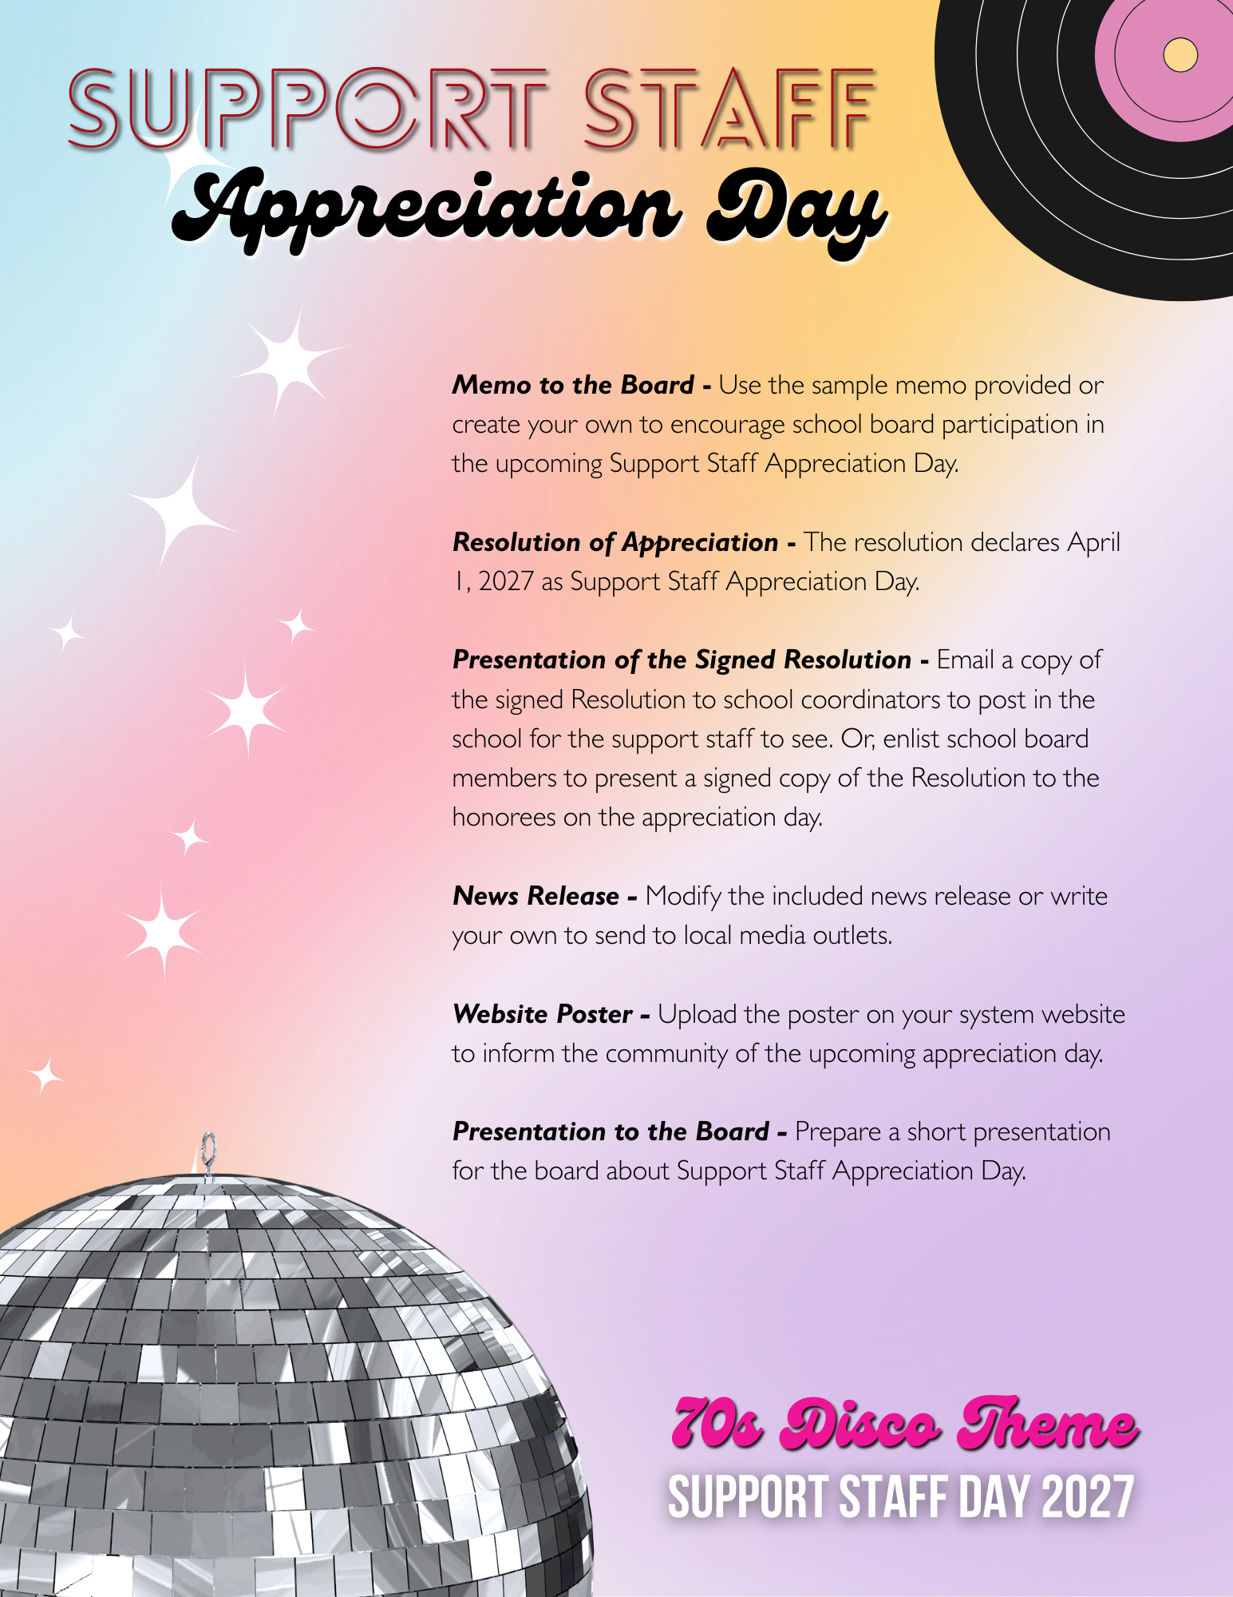


TO: Board of Education
FROM: Superintendent
RE: Support Staff Appreciation Day
DATE: April ________, 2027
I invite you to join me in recognizing the outstanding contributions of our Support Staff on April 1, 2027, as we celebrate Support Staff Appreciation Day. This year’s “1970’s Disco Era” theme offers a fun and engaging way to highlight the energy, teamwork, and positive spirit these individuals bring to our schools each day.
Our Support Staff—including secretaries, bookkeepers, attendance clerks, receptionists, school resource officers, teacher assistants, and nurses—play a vital role in keeping our schools operating smoothly. Their daily efforts ensure that students are supported, environments are welcoming, and school operations remain organized and efficient.
From managing essential tasks to supporting student needs, these dedicated professionals contribute in countless ways that often go unseen but are deeply impactful. Their commitment, reliability, and collaborative approach help create a strong foundation for both teaching and learning. Like a well-coordinated rhythm, their work keeps everything moving forward together.
Enclosed is a Resolution for your consideration that formally recognizes the important role of our Support Staff. I encourage Board members to take part in this celebration by visiting schools and personally sharing messages of appreciation or presenting a signed copy of the Resolution. These gestures serve as a meaningful acknowledgment of their hard work and dedication.
This day provides an opportunity for all of us to express our gratitude and recognize the individuals whose contributions are essential to the success and strength of our school community.
Approved by the __________________ Board of Education in regular session on _______________, 2027.
WHEREAS, the Support Staff of the _______________ School System are an essential part of the school community, contributing their time, expertise, and dedication to support student success and the effective operation of our schools; and
WHEREAS, these valued team members perform a wide range of responsibilities, including administrative support, student supervision, health services, financial management, and instructional assistance, all of which help create a safe, organized, and positive learning environment; and
WHEREAS, our Support Staff—including school resource officers, nurses, attendance clerks, receptionists, bookkeepers, and teacher assistants—consistently demonstrate professionalism, compassion, and a strong commitment to serving students, staff, and families; and
WHEREAS, their collaboration, dependability, and ability to keep our schools running smoothly provide a strong foundation that allows students and educators to thrive; and
WHEREAS, their energy, teamwork, and positive spirit keep our schools moving forward together, much like a well-coordinated rhythm that brings people together and creates a sense of unity; and
NOW, THEREFORE, BE IT RESOLVED that the __________________ Board of Education hereby proclaims April 1, 2027, as Support Staff Appreciation Day; and
BE IT FURTHER RESOLVED that the Board extends its sincere appreciation to all Support Staff members for their dedication, hard work, and meaningful contributions to the success of our schools; and
BE IT FURTHER RESOLVED that the Board encourages each school to participate in recognizing Support Staff through special activities and expressions of gratitude; and
BE IT FURTHER RESOLVED that the Board endorses the use of a “1970’s Disco Era” theme for this year’s Support Staff Appreciation Day, celebrating the vibrant energy, teamwork, and positivity Support Staff bring to their roles—keeping our schools in sync and moving forward together. This theme offers a fun and engaging way to highlight their important contributions and honor their impact on the school community.

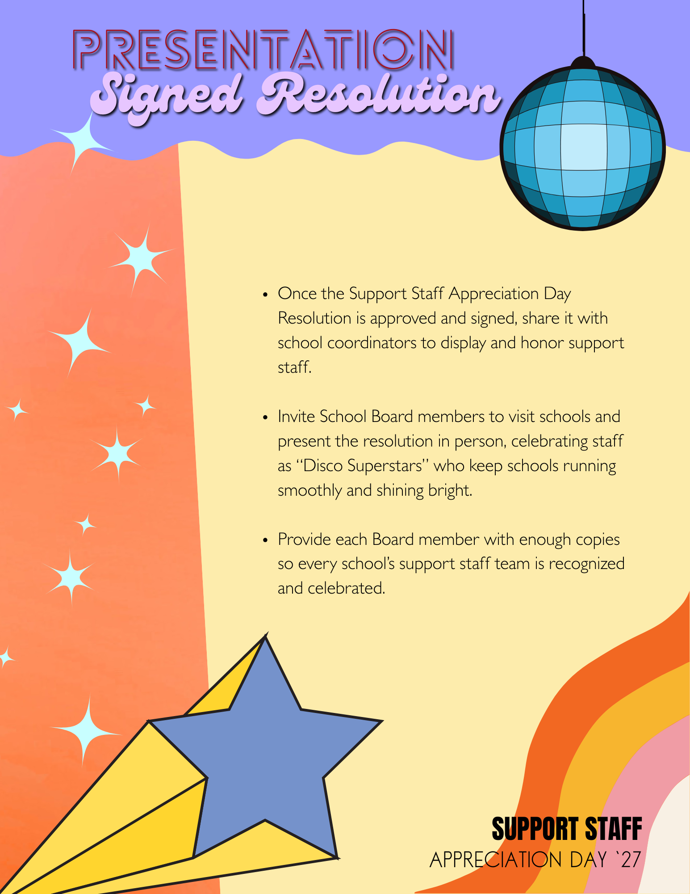


FOR IMMEDIATE RELEASE
DATE: _______________
Students in ___________________ School System are getting ready to turn up the music and shine the spotlight on their incredible Support Staff during Support Staff Appreciation Day on April 1, 2027. This year’s celebration will feature a lively “1970’s Disco Era” theme, bringing energy, fun, and recognition to those who keep our schools moving in rhythm each day.
This special observance honors the dedication and contributions of Support Staff members and reflects the appreciation outlined in the Resolution recently adopted by the Board of Education.
“Our Support Staff—including school resource officers, nurses, attendance clerks, receptionists, bookkeepers, and teacher assistants—play an essential role in the success of our schools,” said Superintendent ____________________. “Like a great disco track, everything runs smoothly because of their steady presence, teamwork, and commitment. We are excited to celebrate them and recognize the positive impact they have on our students and school community.”
Support Staff Appreciation Day is one of eight celebrations held throughout the school year, each recognizing a different group of valued school employees. As part of the Utrust Appreciation Program, students take the lead in planning and participating in themed activities that express gratitude and highlight the important work happening behind the scenes.
From groovy decorations to heartfelt messages of appreciation, this year’s 1970’s Disco Era theme will help students shine a light on the individuals who keep our schools running strong.

