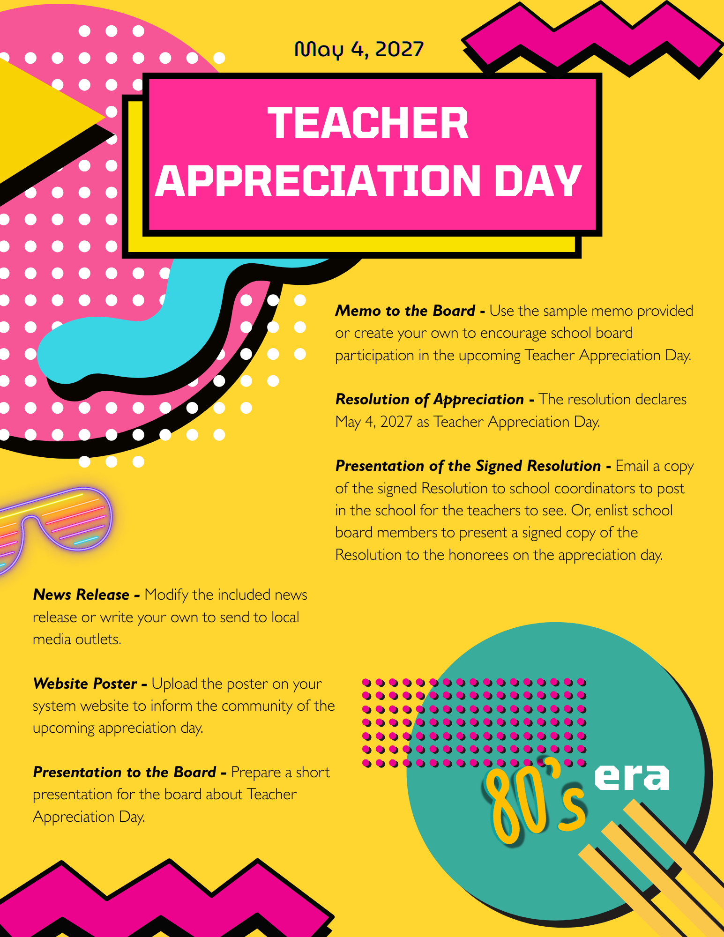


TO: Board of Education
FROM: Superintendent
RE: Support Staff Appreciation Day
DATE: May _______, 2027
Teacher Appreciation Day is set for May 4, 2027. This will be the final Utrust appreciation day celebrated during the school year and is always one of the most meaningful and uplifting moments as we recognize the teachers who make a lasting difference in the lives of our students.
The theme for this year’s Teacher Appreciation Day is “Appreciation Through the Eras: 1980s Edition.” Using the energy and spirit of the 1980s as inspiration, schools will celebrate the creativity, dedication, and positive influence teachers bring to their classrooms each day. Through morning announcements, music, and thoughtful handwritten messages from students, we will take time to recognize the many ways teachers support, encourage, and inspire learning.
Just as the 1980s were known for bold ideas and unforgettable moments, our teachers continue to bring enthusiasm, innovation, and commitment to helping students succeed. Their impact reaches far beyond the classroom as they guide students, build confidence, and help prepare them for the future.
Attached is the Resolution of Appreciation, which I hope you will adopt to formally recognize Teacher Appreciation Day in our school system. Together, we can make this a memorable celebration that honors the dedication and passion our teachers bring to their work every day.

Approved by the __________________ Board of Education in regular session on _______________, 2027.
Whereas, teachers devote their time, talent, and passion to educating the students of our community, helping them grow academically, socially, and personally; and
Whereas, through their dedication and encouragement, these educators inspire students to develop confidence, creativity, and a lifelong love of learning; and
Whereas, teachers play a vital role in preparing students for the future by providing guidance, fostering critical thinking, and creating classrooms where every student has the opportunity to succeed; and
Whereas, the commitment of our teachers extends well beyond daily lessons, as they mentor students, support school activities, and contribute to building strong, positive school communities; and
Whereas, during the 2027 “Appreciation Through the Eras” celebration featuring the 1980s, schools will recognize the energy, creativity, and lasting influence teachers bring to education—reminding us that great teaching, like great music from the decade, continues to inspire generation after generation;
NOW, THEREFORE, BE IT RESOLVED that the _______________ Board of Education hereby designates ______________(Teacher Appreciation Day Date), as Teacher Appreciation Day in all schools across the district; and
BE IT FURTHER RESOLVED that the Board extends its heartfelt appreciation to the teachers of the (Name of School District) for their dedication, professionalism, and unwavering commitment to the success of every student, and encourages students, staff, families, and the community to join in recognizing and celebrating their contributions to education and the lasting impact they have on the lives of students and the future of our community.




Note: Consider attaching the resolution and a photo of the Board Chair presenting it to a veteran teacher to help encourage local media and social media coverage.

FOR IMMEDIATE RELEASE
DATE: [Insert Current Date]
The ________________ School Board has passed a resolution declaring May 4, 2027, as Teacher Appreciation Day, recognizing the incredible dedication and impact of teachers across the district. This year’s celebration will feature an energetic “Appreciation Through the Eras: 1980s Edition” theme.
Inspired by the creativity, bold style, and memorable music of the 1980s, schools throughout the district will find fun and meaningful ways to recognize the teachers who help shape the future for students every day. From retro-inspired decorations to colorful appreciation messages, the celebration will highlight the enthusiasm and commitment teachers bring to their classrooms.
Superintendent [Name] shared, “Our teachers make a lasting difference in the lives of students. Their dedication, creativity, and passion help prepare young people for the future. Teacher Appreciation Day gives us the opportunity to recognize their contributions and thank them for the positive impact they have on our schools.”
Teacher Appreciation Day is part of the district’s Utrust Appreciation Program, which includes eight designated days during the school year that recognize the many individuals who support student success. The program encourages students to practice gratitude while providing leadership opportunities through school-based appreciation events.
Across the district, student-led A-Teams will help organize activities and recognition efforts to celebrate teachers in fun and creative ways inspired by the 1980s theme. The celebrations are designed to express appreciation while building school pride and a stronger culture of gratitude.
As schools prepare to celebrate Teacher Appreciation Day, the district invites the entire community to join in recognizing the teachers who inspire learning, encourage growth, and make a lasting difference in the lives of students.




